BDD200 – Project 2
Hospital Management System

Group 1:
Luka Lazarev – Implemented tables Departments and Doctors.
Duy Bao Khang Nguyen – Implemented tables Patients and Appointments.
Rishi Raj Das – Implemented tables Medical Records, Prescriptions and Medication.

Entity-Relationship Diagram
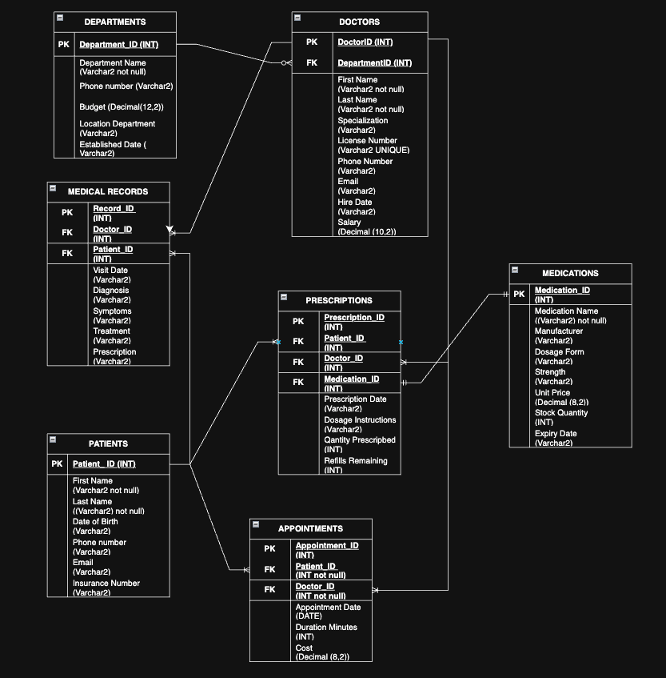

SQL Creation Script
-- Luka Lazarev implemented tables Doctors and Departments.
CREATE TABLE DEPARTMENTS (
DEPARTMENT_ID INT PRIMARY KEY,
DEPARTMENT_NAME VARCHAR2(100) NOT NULL,
LOCATION_DEPARTMENT VARCHAR2(200),
PHONE_NUMBER VARCHAR2(20),
BUDGET DECIMAL(12,2),
ESTABLISHED_DATE VARCHAR2(20)
);

CREATE TABLE DOCTORS (
DOCTOR_ID INT PRIMARY KEY,
FIRST_NAME VARCHAR2(50) NOT NULL,
LAST_NAME VARCHAR2(50) NOT NULL,
SPECIALIZATION VARCHAR2(100),
LICENSE_NUMBER VARCHAR2(20) UNIQUE,
PHONE_NUMBER VARCHAR2(20),
EMAIL VARCHAR2(100),
HIRE_DATE VARCHAR2(20),
SALARY DECIMAL(10,2),
DEPARTMENT_ID INT,
FOREIGN KEY (DEPARTMENT_ID) REFERENCES DEPARTMENTS(DEPARTMENT_ID)
);

-- Duy Bao Khang Nguyen implemented tables Patients and Appointments.
CREATE TABLE PATIENTS (
PATIENT_ID INT PRIMARY KEY,
FIRST_NAME VARCHAR2(50) NOT NULL,
LAST_NAME VARCHAR2(50) NOT NULL,
DATE_OF_BIRTH VARCHAR2(20),
PHONE_NUMBER VARCHAR2(20),
EMAIL VARCHAR2(100),
INSURANCE_NUMBER VARCHAR2(50)
);

CREATE TABLE APPOINTMENTS (
APPOINTMENT_ID INT PRIMARY KEY,
PATIENT_ID INT NOT NULL,
DOCTOR_ID INT NOT NULL,
APPOINTMENT_DATE VARCHAR2(20),
DURATION_MINUTES INT,
COST DECIMAL(8,2),
FOREIGN KEY (PATIENT_ID) REFERENCES PATIENTS(PATIENT_ID),
FOREIGN KEY (DOCTOR_ID) REFERENCES DOCTORS(DOCTOR_ID)
);
-- Rishi Raj Das implemented tables Medical_Records, Prescriptions and Medication.
CREATE TABLE MEDICAL_RECORDS (
RECORD_ID INT PRIMARY KEY,
PATIENT_ID INT NOT NULL,
DOCTOR_ID INT NOT NULL,
VISIT_DATE DATE,
DIAGNOSIS VARCHAR2(500),
SYMPTOMS VARCHAR2(500),
TREATMENT VARCHAR2(500),
PRESCRIPTION VARCHAR2(500),
FOREIGN KEY (PATIENT_ID) REFERENCES PATIENTS(PATIENT_ID),
FOREIGN KEY (DOCTOR_ID) REFERENCES DOCTORS(DOCTOR_ID)
);

CREATE TABLE MEDICATIONS (
MEDICATION_ID INT PRIMARY KEY,
MEDICATION_NAME VARCHAR2(100) NOT NULL,
MANUFACTURER VARCHAR2(100),
DOSAGE_FORM VARCHAR2(50),
STRENGTH VARCHAR2(20),
UNIT_PRICE DECIMAL(8,2),
STOCK_QUANTITY INT,
EXPIRY_DATE VARCHAR(20)
);
CREATE TABLE PRESCRIPTIONS (
PRESCRIPTION_ID INT PRIMARY KEY,
PATIENT_ID INT NOT NULL,
DOCTOR_ID INT NOT NULL,
MEDICATION_ID INT NOT NULL,
PRESCRIPTION_DATE VARCHAR2(20),
DOSAGE_INSTRUCTIONS VARCHAR2(500),
QUANTITY_PRESCRIBED INT,
REFILLS_REMAINING INT,
FOREIGN KEY (PATIENT_ID) REFERENCES PATIENTS(PATIENT_ID),
FOREIGN KEY (DOCTOR_ID) REFERENCES DOCTORS(DOCTOR_ID),
FOREIGN KEY (MEDICATION_ID) REFERENCES MEDICATIONS(MEDICATION_ID)
);

SQL Insertion Script
INSERT INTO DEPARTMENTS (DEPARTMENT_ID, DEPARTMENT_NAME, LOCATION_DEPARTMENT, PHONE_NUMBER, BUDGET, ESTABLISHED_DATE) VALUES (1, 'Cardiology', 'Building A, Floor 3', '555-0101', 2500000.00, '1995-03-15');
INSERT INTO DEPARTMENTS (DEPARTMENT_ID, DEPARTMENT_NAME, LOCATION_DEPARTMENT, PHONE_NUMBER, BUDGET, ESTABLISHED_DATE) VALUES (2, 'Neurology', 'Building B, Floor 2', '555-0102', 2200000.00, '1998-07-22');
INSERT INTO DEPARTMENTS (DEPARTMENT_ID, DEPARTMENT_NAME, LOCATION_DEPARTMENT, PHONE_NUMBER, BUDGET, ESTABLISHED_DATE) VALUES (3, 'Pediatrics', 'Building C, Floor 1', '555-0103', 1800000.00, '1992-01-10');
INSERT INTO DEPARTMENTS (DEPARTMENT_ID, DEPARTMENT_NAME, LOCATION_DEPARTMENT, PHONE_NUMBER, BUDGET, ESTABLISHED_DATE) VALUES (4, 'Emergency Medicine', 'Building A, Floor 1', '555-0104', 3500000.00, '1985-05-01');
INSERT INTO DEPARTMENTS (DEPARTMENT_ID, DEPARTMENT_NAME, LOCATION_DEPARTMENT, PHONE_NUMBER, BUDGET, ESTABLISHED_DATE) VALUES (5, 'Orthopedics', 'Building D, Floor 2', '555-0105', 2800000.00, '1990-11-30');
INSERT INTO DEPARTMENTS (DEPARTMENT_ID, DEPARTMENT_NAME, LOCATION_DEPARTMENT, PHONE_NUMBER, BUDGET, ESTABLISHED_DATE) VALUES (6, 'Oncology', 'Building B, Floor 4', '555-0106', 4200000.00, '2000-02-14');
INSERT INTO DEPARTMENTS (DEPARTMENT_ID, DEPARTMENT_NAME, LOCATION_DEPARTMENT, PHONE_NUMBER, BUDGET, ESTABLISHED_DATE) VALUES (7, 'Radiology', 'Building E, Floor 1', '555-0107', 3200000.00, '1988-09-12');
INSERT INTO DEPARTMENTS (DEPARTMENT_ID, DEPARTMENT_NAME, LOCATION_DEPARTMENT, PHONE_NUMBER, BUDGET, ESTABLISHED_DATE) VALUES (8, 'Psychiatry', 'Building F, Floor 3', '555-0108', 1500000.00, '1996-04-18');
INSERT INTO DEPARTMENTS (DEPARTMENT_ID, DEPARTMENT_NAME, LOCATION_DEPARTMENT, PHONE_NUMBER, BUDGET, ESTABLISHED_DATE) VALUES (9, 'Dermatology', 'Building C, Floor 2', '555-0109', 1200000.00, '1999-08-25');
INSERT INTO DEPARTMENTS (DEPARTMENT_ID, DEPARTMENT_NAME, LOCATION_DEPARTMENT, PHONE_NUMBER, BUDGET, ESTABLISHED_DATE) VALUES (10, 'Gastroenterology', 'Building A, Floor 2', '555-0110', 2000000.00, '1993-12-08');
INSERT INTO DEPARTMENTS (DEPARTMENT_ID, DEPARTMENT_NAME, LOCATION_DEPARTMENT, PHONE_NUMBER, BUDGET, ESTABLISHED_DATE) VALUES (11, 'Pulmonology', 'Building B, Floor 3', '555-0111', 1900000.00, '1997-06-03');
INSERT INTO DEPARTMENTS (DEPARTMENT_ID, DEPARTMENT_NAME, LOCATION_DEPARTMENT, PHONE_NUMBER, BUDGET, ESTABLISHED_DATE) VALUES (12, 'Endocrinology', 'Building D, Floor 1', '555-0112', 1600000.00, '2001-10-20');
INSERT INTO DEPARTMENTS (DEPARTMENT_ID, DEPARTMENT_NAME, LOCATION_DEPARTMENT, PHONE_NUMBER, BUDGET, ESTABLISHED_DATE) VALUES (13, 'Urology', 'Building E, Floor 2', '555-0113', 1700000.00, '1994-03-28');
INSERT INTO DEPARTMENTS (DEPARTMENT_ID, DEPARTMENT_NAME, LOCATION_DEPARTMENT, PHONE_NUMBER, BUDGET, ESTABLISHED_DATE) VALUES (14, 'Ophthalmology', 'Building F, Floor 1', '555-0114', 1400000.00, '2002-05-16');
INSERT INTO DEPARTMENTS (DEPARTMENT_ID, DEPARTMENT_NAME, LOCATION_DEPARTMENT, PHONE_NUMBER, BUDGET, ESTABLISHED_DATE) VALUES (15, 'Anesthesiology', 'Building A, Floor 4', '555-0115', 2300000.00, '1987-11-05');
INSERT INTO DEPARTMENTS (DEPARTMENT_ID, DEPARTMENT_NAME, LOCATION_DEPARTMENT, PHONE_NUMBER, BUDGET, ESTABLISHED_DATE) VALUES (16, 'Pathology', 'Building E, Floor 3', '555-0116', 2100000.00, '1991-01-24');
INSERT INTO DEPARTMENTS (DEPARTMENT_ID, DEPARTMENT_NAME, LOCATION_DEPARTMENT, PHONE_NUMBER, BUDGET, ESTABLISHED_DATE) VALUES (17, 'General Surgery', 'Building D, Floor 3', '555-0117', 3800000.00, '1986-07-11');
INSERT INTO DEPARTMENTS (DEPARTMENT_ID, DEPARTMENT_NAME, LOCATION_DEPARTMENT, PHONE_NUMBER, BUDGET, ESTABLISHED_DATE) VALUES (18, 'Obstetrics and Gynecology', 'Building C, Floor 3', '555-0118', 2600000.00, '1989-09-07');
INSERT INTO DEPARTMENTS (DEPARTMENT_ID, DEPARTMENT_NAME, LOCATION_DEPARTMENT, PHONE_NUMBER, BUDGET, ESTABLISHED_DATE) VALUES (19, 'Rheumatology', 'Building F, Floor 2', '555-0119', 1300000.00, '2003-04-12');
INSERT INTO DEPARTMENTS (DEPARTMENT_ID, DEPARTMENT_NAME, LOCATION_DEPARTMENT, PHONE_NUMBER, BUDGET, ESTABLISHED_DATE) VALUES (20, 'Infectious Disease', 'Building B, Floor 1', '555-0120', 1800000.00, '2005-12-01');

INSERT INTO DOCTORS (DOCTOR_ID, FIRST_NAME, LAST_NAME, SPECIALIZATION, LICENSE_NUMBER, PHONE_NUMBER, EMAIL, HIRE_DATE, SALARY, DEPARTMENT_ID) VALUES (1, 'Michael', 'Johnson', 'Cardiologist', 'MD001234', '555-1001', 'mjohnson@hospital.com', '2010-03-15', 285000.00, 1);
INSERT INTO DOCTORS (DOCTOR_ID, FIRST_NAME, LAST_NAME, SPECIALIZATION, LICENSE_NUMBER, PHONE_NUMBER, EMAIL, HIRE_DATE, SALARY, DEPARTMENT_ID) VALUES (2, 'Sarah', 'Williams', 'Neurologist', 'MD001235', '555-1002', 'swilliams@hospital.com', '2012-07-22', 275000.00, 2);
INSERT INTO DOCTORS (DOCTOR_ID, FIRST_NAME, LAST_NAME, SPECIALIZATION, LICENSE_NUMBER, PHONE_NUMBER, EMAIL, HIRE_DATE, SALARY, DEPARTMENT_ID) VALUES (3, 'David', 'Brown', 'Pediatrician', 'MD001236', '555-1003', 'dbrown@hospital.com', '2008-01-10', 195000.00, 3);
INSERT INTO DOCTORS (DOCTOR_ID, FIRST_NAME, LAST_NAME, SPECIALIZATION, LICENSE_NUMBER, PHONE_NUMBER, EMAIL, HIRE_DATE, SALARY, DEPARTMENT_ID) VALUES (4, 'Emily', 'Davis', 'Emergency Physician', 'MD001237', '555-1004', 'edavis@hospital.com', '2015-05-01', 245000.00, 4);
INSERT INTO DOCTORS (DOCTOR_ID, FIRST_NAME, LAST_NAME, SPECIALIZATION, LICENSE_NUMBER, PHONE_NUMBER, EMAIL, HIRE_DATE, SALARY, DEPARTMENT_ID) VALUES (5, 'Robert', 'Miller', 'Orthopedic Surgeon', 'MD001238', '555-1005', 'rmiller@hospital.com', '2009-11-30', 320000.00, 5);
INSERT INTO DOCTORS (DOCTOR_ID, FIRST_NAME, LAST_NAME, SPECIALIZATION, LICENSE_NUMBER, PHONE_NUMBER, EMAIL, HIRE_DATE, SALARY, DEPARTMENT_ID) VALUES (6, 'Jennifer', 'Wilson', 'Oncologist', 'MD001239', '555-1006', 'jwilson@hospital.com', '2013-02-14', 295000.00, 6);
INSERT INTO DOCTORS (DOCTOR_ID, FIRST_NAME, LAST_NAME, SPECIALIZATION, LICENSE_NUMBER, PHONE_NUMBER, EMAIL, HIRE_DATE, SALARY, DEPARTMENT_ID) VALUES (7, 'Christopher', 'Moore', 'Radiologist', 'MD001240', '555-1007', 'cmoore@hospital.com', '2011-09-12', 265000.00, 7);
INSERT INTO DOCTORS (DOCTOR_ID, FIRST_NAME, LAST_NAME, SPECIALIZATION, LICENSE_NUMBER, PHONE_NUMBER, EMAIL, HIRE_DATE, SALARY, DEPARTMENT_ID) VALUES (8, 'Lisa', 'Taylor', 'Psychiatrist', 'MD001241', '555-1008', 'ltaylor@hospital.com', '2014-04-18', 225000.00, 8);
INSERT INTO DOCTORS (DOCTOR_ID, FIRST_NAME, LAST_NAME, SPECIALIZATION, LICENSE_NUMBER, PHONE_NUMBER, EMAIL, HIRE_DATE, SALARY, DEPARTMENT_ID) VALUES (9, 'James', 'Anderson', 'Dermatologist', 'MD001242', '555-1009', 'janderson@hospital.com', '2016-08-25', 210000.00, 9);
INSERT INTO DOCTORS (DOCTOR_ID, FIRST_NAME, LAST_NAME, SPECIALIZATION, LICENSE_NUMBER, PHONE_NUMBER, EMAIL, HIRE_DATE, SALARY, DEPARTMENT_ID) VALUES (10, 'Maria', 'Thomas', 'Gastroenterologist', 'MD001243', '555-1010', 'mthomas@hospital.com', '2007-12-08', 255000.00, 10);
INSERT INTO DOCTORS (DOCTOR_ID, FIRST_NAME, LAST_NAME, SPECIALIZATION, LICENSE_NUMBER, PHONE_NUMBER, EMAIL, HIRE_DATE, SALARY, DEPARTMENT_ID) VALUES (11, 'William', 'Jackson', 'Pulmonologist', 'MD001244', '555-1011', 'wjackson@hospital.com', '2018-06-03', 235000.00, 11);
INSERT INTO DOCTORS (DOCTOR_ID, FIRST_NAME, LAST_NAME, SPECIALIZATION, LICENSE_NUMBER, PHONE_NUMBER, EMAIL, HIRE_DATE, SALARY, DEPARTMENT_ID) VALUES (12, 'Amanda', 'White', 'Endocrinologist', 'MD001245', '555-1012', 'awhite@hospital.com', '2017-10-20', 215000.00, 12);
INSERT INTO DOCTORS (DOCTOR_ID, FIRST_NAME, LAST_NAME, SPECIALIZATION, LICENSE_NUMBER, PHONE_NUMBER, EMAIL, HIRE_DATE, SALARY, DEPARTMENT_ID) VALUES (13, 'Daniel', 'Harris', 'Urologist', 'MD001246', '555-1013', 'dharris@hospital.com', '2006-03-28', 280000.00, 13);
INSERT INTO DOCTORS (DOCTOR_ID, FIRST_NAME, LAST_NAME, SPECIALIZATION, LICENSE_NUMBER, PHONE_NUMBER, EMAIL, HIRE_DATE, SALARY, DEPARTMENT_ID) VALUES (14, 'Jessica', 'Martin', 'Ophthalmologist', 'MD001247', '555-1014', 'jmartin@hospital.com', '2019-05-16', 205000.00, 14);
INSERT INTO DOCTORS (DOCTOR_ID, FIRST_NAME, LAST_NAME, SPECIALIZATION, LICENSE_NUMBER, PHONE_NUMBER, EMAIL, HIRE_DATE, SALARY, DEPARTMENT_ID) VALUES (15, 'Mark', 'Thompson', 'Anesthesiologist', 'MD001248', '555-1015', 'mthompson@hospital.com', '2005-11-05', 315000.00, 15);
INSERT INTO DOCTORS (DOCTOR_ID, FIRST_NAME, LAST_NAME, SPECIALIZATION, LICENSE_NUMBER, PHONE_NUMBER, EMAIL, HIRE_DATE, SALARY, DEPARTMENT_ID) VALUES (16, 'Nicole', 'Garcia', 'Pathologist', 'MD001249', '555-1016', 'ngarcia@hospital.com', '2020-01-24', 195000.00, 16);
INSERT INTO DOCTORS (DOCTOR_ID, FIRST_NAME, LAST_NAME, SPECIALIZATION, LICENSE_NUMBER, PHONE_NUMBER, EMAIL, HIRE_DATE, SALARY, DEPARTMENT_ID) VALUES (17, 'Kevin', 'Martinez', 'General Surgeon', 'MD001250', '555-1017', 'kmartinez@hospital.com', '2004-07-11', 335000.00, 17);
INSERT INTO DOCTORS (DOCTOR_ID, FIRST_NAME, LAST_NAME, SPECIALIZATION, LICENSE_NUMBER, PHONE_NUMBER, EMAIL, HIRE_DATE, SALARY, DEPARTMENT_ID) VALUES (18, 'Rachel', 'Robinson', 'Obstetrician', 'MD001251', '555-1018', 'rrobinson@hospital.com', '2021-09-07', 270000.00, 18);
INSERT INTO DOCTORS (DOCTOR_ID, FIRST_NAME, LAST_NAME, SPECIALIZATION, LICENSE_NUMBER, PHONE_NUMBER, EMAIL, HIRE_DATE, SALARY, DEPARTMENT_ID) VALUES (19, 'Steven', 'Clark', 'Rheumatologist', 'MD001252', '555-1019', 'sclark@hospital.com', '2022-04-12', 240000.00, 19);
INSERT INTO DOCTORS (DOCTOR_ID, FIRST_NAME, LAST_NAME, SPECIALIZATION, LICENSE_NUMBER, PHONE_NUMBER, EMAIL, HIRE_DATE, SALARY, DEPARTMENT_ID) VALUES (20, 'Karen', 'Rodriguez', 'Infectious Disease Specialist', 'MD001253', '555-1020', 'krodriguez@hospital.com', '2023-12-01', 250000.00, 20);

INSERT INTO PATIENTS (PATIENT_ID, FIRST_NAME, LAST_NAME, DATE_OF_BIRTH, PHONE_NUMBER, EMAIL, INSURANCE_NUMBER) VALUES (1, 'John', 'Smith', '1980-05-15', '555-2001', 'john.smith@email.com', 'INS001234567');
INSERT INTO PATIENTS (PATIENT_ID, FIRST_NAME, LAST_NAME, DATE_OF_BIRTH, PHONE_NUMBER, EMAIL, INSURANCE_NUMBER) VALUES (2, 'Mary', 'Johnson', '1975-12-03', '555-2002', 'mary.johnson@email.com', 'INS001234568');
INSERT INTO PATIENTS (PATIENT_ID, FIRST_NAME, LAST_NAME, DATE_OF_BIRTH, PHONE_NUMBER, EMAIL, INSURANCE_NUMBER) VALUES (3, 'Robert', 'Williams', '1988-08-22', '555-2003', 'robert.williams@email.com', 'INS001234569');
INSERT INTO PATIENTS (PATIENT_ID, FIRST_NAME, LAST_NAME, DATE_OF_BIRTH, PHONE_NUMBER, EMAIL, INSURANCE_NUMBER) VALUES (4, 'Patricia', 'Brown', '1965-04-18', '555-2004', 'patricia.brown@email.com', 'INS001234570');
INSERT INTO PATIENTS (PATIENT_ID, FIRST_NAME, LAST_NAME, DATE_OF_BIRTH, PHONE_NUMBER, EMAIL, INSURANCE_NUMBER) VALUES (5, 'Jennifer', 'Davis', '1992-11-07', '555-2005', 'jennifer.davis@email.com', 'INS001234571');
INSERT INTO PATIENTS (PATIENT_ID, FIRST_NAME, LAST_NAME, DATE_OF_BIRTH, PHONE_NUMBER, EMAIL, INSURANCE_NUMBER) VALUES (6, 'Michael', 'Miller', '1970-09-25', '555-2006', 'michael.miller@email.com', 'INS001234572');
INSERT INTO PATIENTS (PATIENT_ID, FIRST_NAME, LAST_NAME, DATE_OF_BIRTH, PHONE_NUMBER, EMAIL, INSURANCE_NUMBER) VALUES (7, 'Linda', 'Wilson', '1983-02-14', '555-2007', 'linda.wilson@email.com', 'INS001234573');
INSERT INTO PATIENTS (PATIENT_ID, FIRST_NAME, LAST_NAME, DATE_OF_BIRTH, PHONE_NUMBER, EMAIL, INSURANCE_NUMBER) VALUES (8, 'William', 'Moore', '1955-07-30', '555-2008', 'william.moore@email.com', 'INS001234574');
INSERT INTO PATIENTS (PATIENT_ID, FIRST_NAME, LAST_NAME, DATE_OF_BIRTH, PHONE_NUMBER, EMAIL, INSURANCE_NUMBER) VALUES (9, 'Elizabeth', 'Taylor', '1995-01-12', '555-2009', 'elizabeth.taylor@email.com', 'INS001234575');
INSERT INTO PATIENTS (PATIENT_ID, FIRST_NAME, LAST_NAME, DATE_OF_BIRTH, PHONE_NUMBER, EMAIL, INSURANCE_NUMBER) VALUES (10, 'David', 'Anderson', '1978-06-08', '555-2010', 'david.anderson@email.com', 'INS001234576');
INSERT INTO PATIENTS (PATIENT_ID, FIRST_NAME, LAST_NAME, DATE_OF_BIRTH, PHONE_NUMBER, EMAIL, INSURANCE_NUMBER) VALUES (11, 'Barbara', 'Thomas', '1962-10-20', '555-2011', 'barbara.thomas@email.com', 'INS001234577');
INSERT INTO PATIENTS (PATIENT_ID, FIRST_NAME, LAST_NAME, DATE_OF_BIRTH, PHONE_NUMBER, EMAIL, INSURANCE_NUMBER) VALUES (12, 'Richard', 'Jackson', '1990-03-17', '555-2012', 'richard.jackson@email.com', 'INS001234578');
INSERT INTO PATIENTS (PATIENT_ID, FIRST_NAME, LAST_NAME, DATE_OF_BIRTH, PHONE_NUMBER, EMAIL, INSURANCE_NUMBER) VALUES (13, 'Susan', 'White', '1985-12-09', '555-2013', 'susan.white@email.com', 'INS001234579');
INSERT INTO PATIENTS (PATIENT_ID, FIRST_NAME, LAST_NAME, DATE_OF_BIRTH, PHONE_NUMBER, EMAIL, INSURANCE_NUMBER) VALUES (14, 'Joseph', 'Harris', '1973-05-28', '555-2014', 'joseph.harris@email.com', 'INS001234580');
INSERT INTO PATIENTS (PATIENT_ID, FIRST_NAME, LAST_NAME, DATE_OF_BIRTH, PHONE_NUMBER, EMAIL, INSURANCE_NUMBER) VALUES (15, 'Jessica', 'Martin', '1987-09-11', '555-2015', 'jessica.martin@email.com', 'INS001234581');
INSERT INTO PATIENTS (PATIENT_ID, FIRST_NAME, LAST_NAME, DATE_OF_BIRTH, PHONE_NUMBER, EMAIL, INSURANCE_NUMBER) VALUES (16, 'Thomas', 'Thompson', '1960-01-05', '555-2016', 'thomas.thompson@email.com', 'INS001234582');
INSERT INTO PATIENTS (PATIENT_ID, FIRST_NAME, LAST_NAME, DATE_OF_BIRTH, PHONE_NUMBER, EMAIL, INSURANCE_NUMBER) VALUES (17, 'Sarah', 'Garcia', '1993-08-23', '555-2017', 'sarah.garcia@email.com', 'INS001234583');
INSERT INTO PATIENTS (PATIENT_ID, FIRST_NAME, LAST_NAME, DATE_OF_BIRTH, PHONE_NUMBER, EMAIL, INSURANCE_NUMBER) VALUES (18, 'Charles', 'Martinez', '1968-04-16', '555-2018', 'charles.martinez@email.com', 'INS001234584');
INSERT INTO PATIENTS (PATIENT_ID, FIRST_NAME, LAST_NAME, DATE_OF_BIRTH, PHONE_NUMBER, EMAIL, INSURANCE_NUMBER) VALUES (19, 'Nancy', 'Robinson', '1976-11-02', '555-2019', 'nancy.robinson@email.com', 'INS001234585');
INSERT INTO PATIENTS (PATIENT_ID, FIRST_NAME, LAST_NAME, DATE_OF_BIRTH, PHONE_NUMBER, EMAIL, INSURANCE_NUMBER) VALUES (20, 'Christopher', 'Clark', '1982-07-19', '555-2020', 'christopher.clark@email.com', 'INS001234586');

INSERT INTO MEDICATIONS (MEDICATION_ID, MEDICATION_NAME, MANUFACTURER, DOSAGE_FORM, STRENGTH, UNIT_PRICE, STOCK_QUANTITY, EXPIRY_DATE) VALUES (1, 'Lisinopril', 'Pfizer', 'Tablet', '10mg', 0.50, 5000, DATE '2025-12-31');
INSERT INTO MEDICATIONS (MEDICATION_ID, MEDICATION_NAME, MANUFACTURER, DOSAGE_FORM, STRENGTH, UNIT_PRICE, STOCK_QUANTITY, EXPIRY_DATE) VALUES (2, 'Acetaminophen', 'Johnson & Johnson', 'Tablet', '500mg', 0.15, 10000, DATE '2026-06-30');
INSERT INTO MEDICATIONS (MEDICATION_ID, MEDICATION_NAME, MANUFACTURER, DOSAGE_FORM, STRENGTH, UNIT_PRICE, STOCK_QUANTITY, EXPIRY_DATE) VALUES (3, 'Ibuprofen', 'Advil', 'Tablet', '600mg', 0.25, 8000, DATE '2025-09-15');
INSERT INTO MEDICATIONS (MEDICATION_ID, MEDICATION_NAME, MANUFACTURER, DOSAGE_FORM, STRENGTH, UNIT_PRICE, STOCK_QUANTITY, EXPIRY_DATE) VALUES (4, 'Sumatriptan', 'GlaxoSmithKline', 'Tablet', '50mg', 15.50, 500, DATE '2025-03-20');
INSERT INTO MEDICATIONS (MEDICATION_ID, MEDICATION_NAME, MANUFACTURER, DOSAGE_FORM, STRENGTH, UNIT_PRICE, STOCK_QUANTITY, EXPIRY_DATE) VALUES (5, 'Doxorubicin', 'Novartis', 'Injection', '50mg', 125.00, 200, DATE '2024-11-10');
INSERT INTO MEDICATIONS (MEDICATION_ID, MEDICATION_NAME, MANUFACTURER, DOSAGE_FORM, STRENGTH, UNIT_PRICE, STOCK_QUANTITY, EXPIRY_DATE) VALUES (6, 'Ciprofloxacin', 'Bayer', 'Tablet', '500mg', 2.75, 3000, DATE '2026-01-25');
INSERT INTO MEDICATIONS (MEDICATION_ID, MEDICATION_NAME, MANUFACTURER, DOSAGE_FORM, STRENGTH, UNIT_PRICE, STOCK_QUANTITY, EXPIRY_DATE) VALUES (7, 'Sertraline', 'Zoloft', 'Tablet', '50mg', 1.85, 2500, DATE '2025-08-12');
INSERT INTO MEDICATIONS (MEDICATION_ID, MEDICATION_NAME, MANUFACTURER, DOSAGE_FORM, STRENGTH, UNIT_PRICE, STOCK_QUANTITY, EXPIRY_DATE) VALUES (8, 'Azithromycin', 'Pfizer', 'Tablet', '250mg', 3.25, 1500, DATE '2025-04-18');
INSERT INTO MEDICATIONS (MEDICATION_ID, MEDICATION_NAME, MANUFACTURER, DOSAGE_FORM, STRENGTH, UNIT_PRICE, STOCK_QUANTITY, EXPIRY_DATE) VALUES (9, 'Hydrocortisone', 'Teva', 'Cream', '1%', 8.50, 750, DATE '2025-07-30');
INSERT INTO MEDICATIONS (MEDICATION_ID, MEDICATION_NAME, MANUFACTURER, DOSAGE_FORM, STRENGTH, UNIT_PRICE, STOCK_QUANTITY, EXPIRY_DATE) VALUES (10, 'Omeprazole', 'AstraZeneca', 'Capsule', '20mg', 0.85, 4000, DATE '2026-02-14');
INSERT INTO MEDICATIONS (MEDICATION_ID, MEDICATION_NAME, MANUFACTURER, DOSAGE_FORM, STRENGTH, UNIT_PRICE, STOCK_QUANTITY, EXPIRY_DATE) VALUES (11, 'Albuterol', 'Ventolin', 'Inhaler', '90mcg', 45.00, 300, DATE '2025-10-05');
INSERT INTO MEDICATIONS (MEDICATION_ID, MEDICATION_NAME, MANUFACTURER, DOSAGE_FORM, STRENGTH, UNIT_PRICE, STOCK_QUANTITY, EXPIRY_DATE) VALUES (12, 'Metformin', 'Bristol Myers', 'Tablet', '500mg', 0.35, 6000, DATE '2026-05-22');
INSERT INTO MEDICATIONS (MEDICATION_ID, MEDICATION_NAME, MANUFACTURER, DOSAGE_FORM, STRENGTH, UNIT_PRICE, STOCK_QUANTITY, EXPIRY_DATE) VALUES (13, 'Morphine', 'Purdue Pharma', 'Tablet', '10mg', 2.50, 800, DATE '2025-01-15');
INSERT INTO MEDICATIONS (MEDICATION_ID, MEDICATION_NAME, MANUFACTURER, DOSAGE_FORM, STRENGTH, UNIT_PRICE, STOCK_QUANTITY, EXPIRY_DATE) VALUES (14, 'Prednisolone', 'Allergan', 'Drops', '1%', 12.75, 400, DATE '2024-12-08');
INSERT INTO MEDICATIONS (MEDICATION_ID, MEDICATION_NAME, MANUFACTURER, DOSAGE_FORM, STRENGTH, UNIT_PRICE, STOCK_QUANTITY, EXPIRY_DATE) VALUES (15, 'Propofol', 'Fresenius', 'Injection', '10mg/ml', 8.25, 600, DATE '2024-09-30');
INSERT INTO MEDICATIONS (MEDICATION_ID, MEDICATION_NAME, MANUFACTURER, DOSAGE_FORM, STRENGTH, UNIT_PRICE, STOCK_QUANTITY, EXPIRY_DATE) VALUES (16, 'Iron Sulfate', 'Nature Made', 'Tablet', '325mg', 0.45, 3500, DATE '2026-03-10');
INSERT INTO MEDICATIONS (MEDICATION_ID, MEDICATION_NAME, MANUFACTURER, DOSAGE_FORM, STRENGTH, UNIT_PRICE, STOCK_QUANTITY, EXPIRY_DATE) VALUES (17, 'Ondansetron', 'GlaxoSmithKline', 'Tablet', '4mg', 5.50, 1200, DATE '2025-11-28');
INSERT INTO MEDICATIONS (MEDICATION_ID, MEDICATION_NAME, MANUFACTURER, DOSAGE_FORM, STRENGTH, UNIT_PRICE, STOCK_QUANTITY, EXPIRY_DATE) VALUES (18, 'Folic Acid', 'CVS Health', 'Tablet', '400mcg', 0.20, 4500, DATE '2026-07-16');
INSERT INTO MEDICATIONS (MEDICATION_ID, MEDICATION_NAME, MANUFACTURER, DOSAGE_FORM, STRENGTH, UNIT_PRICE, STOCK_QUANTITY, EXPIRY_DATE) VALUES (19, 'Methotrexate', 'Immunex', 'Tablet', '15mg', 18.75, 350, DATE '2025-06-03');
INSERT INTO MEDICATIONS (MEDICATION_ID, MEDICATION_NAME, MANUFACTURER, DOSAGE_FORM, STRENGTH, UNIT_PRICE, STOCK_QUANTITY, EXPIRY_DATE) VALUES (20, 'Paxlovid', 'Pfizer', 'Tablet', '150mg', 89.50, 150, DATE '2024-10-12');

INSERT INTO APPOINTMENTS (APPOINTMENT_ID, PATIENT_ID, DOCTOR_ID, APPOINTMENT_DATE, DURATION_MINUTES, COST) VALUES (1, 1, 1, DATE '2024-01-15', 45, 250.00);
INSERT INTO APPOINTMENTS (APPOINTMENT_ID, PATIENT_ID, DOCTOR_ID, APPOINTMENT_DATE, DURATION_MINUTES, COST) VALUES (2, 2, 2, DATE '2024-01-16', 60, 350.00);
INSERT INTO APPOINTMENTS (APPOINTMENT_ID, PATIENT_ID, DOCTOR_ID, APPOINTMENT_DATE, DURATION_MINUTES, COST) VALUES (3, 3, 3, DATE '2024-01-17', 30, 150.00);
INSERT INTO APPOINTMENTS (APPOINTMENT_ID, PATIENT_ID, DOCTOR_ID, APPOINTMENT_DATE, DURATION_MINUTES, COST) VALUES (4, 4, 4, DATE '2024-01-18', 20, 500.00);
INSERT INTO APPOINTMENTS (APPOINTMENT_ID, PATIENT_ID, DOCTOR_ID, APPOINTMENT_DATE, DURATION_MINUTES, COST) VALUES (5, 5, 5, DATE '2024-01-19', 45, 400.00);
INSERT INTO APPOINTMENTS (APPOINTMENT_ID, PATIENT_ID, DOCTOR_ID, APPOINTMENT_DATE, DURATION_MINUTES, COST) VALUES (6, 6, 6, DATE '2024-01-20', 60, 600.00);
INSERT INTO APPOINTMENTS (APPOINTMENT_ID, PATIENT_ID, DOCTOR_ID, APPOINTMENT_DATE, DURATION_MINUTES, COST) VALUES (7, 7, 7, DATE '2024-01-21', 30, 200.00);
INSERT INTO APPOINTMENTS (APPOINTMENT_ID, PATIENT_ID, DOCTOR_ID, APPOINTMENT_DATE, DURATION_MINUTES, COST) VALUES (8, 8, 8, DATE '2024-01-22', 50, 300.00);
INSERT INTO APPOINTMENTS (APPOINTMENT_ID, PATIENT_ID, DOCTOR_ID, APPOINTMENT_DATE, DURATION_MINUTES, COST) VALUES (9, 9, 9, DATE '2024-01-23', 25, 175.00);
INSERT INTO APPOINTMENTS (APPOINTMENT_ID, PATIENT_ID, DOCTOR_ID, APPOINTMENT_DATE, DURATION_MINUTES, COST) VALUES (10, 10, 10, DATE '2024-01-24', 40, 225.00);
INSERT INTO APPOINTMENTS (APPOINTMENT_ID, PATIENT_ID, DOCTOR_ID, APPOINTMENT_DATE, DURATION_MINUTES, COST) VALUES (11, 11, 11, DATE '2024-01-25', 45, 275.00);
INSERT INTO APPOINTMENTS (APPOINTMENT_ID, PATIENT_ID, DOCTOR_ID, APPOINTMENT_DATE, DURATION_MINUTES, COST) VALUES (12, 12, 12, DATE '2024-01-26', 35, 185.00);
INSERT INTO APPOINTMENTS (APPOINTMENT_ID, PATIENT_ID, DOCTOR_ID, APPOINTMENT_DATE, DURATION_MINUTES, COST) VALUES (13, 13, 13, DATE '2024-01-27', 30, 220.00);
INSERT INTO APPOINTMENTS (APPOINTMENT_ID, PATIENT_ID, DOCTOR_ID, APPOINTMENT_DATE, DURATION_MINUTES, COST) VALUES (14, 14, 14, DATE '2024-01-28', 25, 165.00);
INSERT INTO APPOINTMENTS (APPOINTMENT_ID, PATIENT_ID, DOCTOR_ID, APPOINTMENT_DATE, DURATION_MINUTES, COST) VALUES (15, 15, 15, DATE '2024-01-29', 120, 800.00);
INSERT INTO APPOINTMENTS (APPOINTMENT_ID, PATIENT_ID, DOCTOR_ID, APPOINTMENT_DATE, DURATION_MINUTES, COST) VALUES (16, 16, 16, DATE '2024-01-30', 40, 190.00);
INSERT INTO APPOINTMENTS (APPOINTMENT_ID, PATIENT_ID, DOCTOR_ID, APPOINTMENT_DATE, DURATION_MINUTES, COST) VALUES (17, 17, 17, DATE '2024-01-31', 90, 750.00);
INSERT INTO APPOINTMENTS (APPOINTMENT_ID, PATIENT_ID, DOCTOR_ID, APPOINTMENT_DATE, DURATION_MINUTES, COST) VALUES (18, 18, 18, DATE '2024-02-01', 45, 280.00);
INSERT INTO APPOINTMENTS (APPOINTMENT_ID, PATIENT_ID, DOCTOR_ID, APPOINTMENT_DATE, DURATION_MINUTES, COST) VALUES (19, 19, 19, DATE '2024-02-02', 35, 195.00);
INSERT INTO APPOINTMENTS (APPOINTMENT_ID, PATIENT_ID, DOCTOR_ID, APPOINTMENT_DATE, DURATION_MINUTES, COST) VALUES (20, 20, 20, DATE '2024-02-03', 50, 325.00);

INSERT INTO MEDICAL_RECORDS (RECORD_ID, PATIENT_ID, DOCTOR_ID, VISIT_DATE, DIAGNOSIS, SYMPTOMS, TREATMENT, PRESCRIPTION) VALUES (1, 1, 1, DATE '2024-01-15', 'Hypertension', 'High blood pressure', 'Lifestyle changes', 'Lisinopril');
INSERT INTO MEDICAL_RECORDS (RECORD_ID, PATIENT_ID, DOCTOR_ID, VISIT_DATE, DIAGNOSIS, SYMPTOMS, TREATMENT, PRESCRIPTION) VALUES (2, 2, 2, DATE '2024-01-16', 'Migraine', 'Severe headache', 'Pain management', 'Sumatriptan');
INSERT INTO MEDICAL_RECORDS (RECORD_ID, PATIENT_ID, DOCTOR_ID, VISIT_DATE, DIAGNOSIS, SYMPTOMS, TREATMENT, PRESCRIPTION) VALUES (3, 3, 3, DATE '2024-01-17', 'Common cold', 'Runny nose cough', 'Rest and fluids', 'Acetaminophen');
INSERT INTO MEDICAL_RECORDS (RECORD_ID, PATIENT_ID, DOCTOR_ID, VISIT_DATE, DIAGNOSIS, SYMPTOMS, TREATMENT, PRESCRIPTION) VALUES (4, 4, 4, DATE '2024-01-18', 'Laceration', 'Cut on hand', 'Sutures', 'Antibiotic ointment');
INSERT INTO MEDICAL_RECORDS (RECORD_ID, PATIENT_ID, DOCTOR_ID, VISIT_DATE, DIAGNOSIS, SYMPTOMS, TREATMENT, PRESCRIPTION) VALUES (5, 5, 5, DATE '2024-01-19', 'Sprained ankle', 'Ankle pain swelling', 'Rest ice compression', 'Ibuprofen');
INSERT INTO MEDICAL_RECORDS (RECORD_ID, PATIENT_ID, DOCTOR_ID, VISIT_DATE, DIAGNOSIS, SYMPTOMS, TREATMENT, PRESCRIPTION) VALUES (6, 6, 6, DATE '2024-01-20', 'Breast cancer', 'Lump in breast', 'Chemotherapy', 'Doxorubicin');
INSERT INTO MEDICAL_RECORDS (RECORD_ID, PATIENT_ID, DOCTOR_ID, VISIT_DATE, DIAGNOSIS, SYMPTOMS, TREATMENT, PRESCRIPTION) VALUES (7, 7, 7, DATE '2024-01-21', 'Pneumonia', 'Chest pain cough', 'Chest X-ray', 'Azithromycin');
INSERT INTO MEDICAL_RECORDS (RECORD_ID, PATIENT_ID, DOCTOR_ID, VISIT_DATE, DIAGNOSIS, SYMPTOMS, TREATMENT, PRESCRIPTION) VALUES (8, 8, 8, DATE '2024-01-22', 'Depression', 'Mood changes fatigue', 'Counseling therapy', 'Sertraline');
INSERT INTO MEDICAL_RECORDS (RECORD_ID, PATIENT_ID, DOCTOR_ID, VISIT_DATE, DIAGNOSIS, SYMPTOMS, TREATMENT, PRESCRIPTION) VALUES (9, 9, 9, DATE '2024-01-23', 'Eczema', 'Itchy skin rash', 'Topical treatment', 'Hydrocortisone cream');
INSERT INTO MEDICAL_RECORDS (RECORD_ID, PATIENT_ID, DOCTOR_ID, VISIT_DATE, DIAGNOSIS, SYMPTOMS, TREATMENT, PRESCRIPTION) VALUES (10, 10, 10, DATE '2024-01-24', 'GERD', 'Heartburn acid reflux', 'Dietary changes', 'Omeprazole');
INSERT INTO MEDICAL_RECORDS (RECORD_ID, PATIENT_ID, DOCTOR_ID, VISIT_DATE, DIAGNOSIS, SYMPTOMS, TREATMENT, PRESCRIPTION) VALUES (11, 11, 11, DATE '2024-01-25', 'Asthma', 'Shortness of breath', 'Inhaler therapy', 'Albuterol inhaler');
INSERT INTO MEDICAL_RECORDS (RECORD_ID, PATIENT_ID, DOCTOR_ID, VISIT_DATE, DIAGNOSIS, SYMPTOMS, TREATMENT, PRESCRIPTION) VALUES (12, 12, 12, DATE '2024-01-26', 'Type 2 diabetes', 'High blood sugar', 'Diet and exercise', 'Metformin');
INSERT INTO MEDICAL_RECORDS (RECORD_ID, PATIENT_ID, DOCTOR_ID, VISIT_DATE, DIAGNOSIS, SYMPTOMS, TREATMENT, PRESCRIPTION) VALUES (13, 13, 13, DATE '2024-01-27', 'Kidney stones', 'Severe back pain', 'Pain management', 'Hydrocodone');
INSERT INTO MEDICAL_RECORDS (RECORD_ID, PATIENT_ID, DOCTOR_ID, VISIT_DATE, DIAGNOSIS, SYMPTOMS, TREATMENT, PRESCRIPTION) VALUES (14, 14, 14, DATE '2024-01-28', 'Cataracts', 'Blurry vision', 'Surgery consultation', 'Eye drops');
INSERT INTO MEDICAL_RECORDS (RECORD_ID, PATIENT_ID, DOCTOR_ID, VISIT_DATE, DIAGNOSIS, SYMPTOMS, TREATMENT, PRESCRIPTION) VALUES (15, 15, 15, DATE '2024-01-29', 'General anesthesia', 'Pre-surgery eval', 'Anesthesia plan', 'Propofol');
INSERT INTO MEDICAL_RECORDS (RECORD_ID, PATIENT_ID, DOCTOR_ID, VISIT_DATE, DIAGNOSIS, SYMPTOMS, TREATMENT, PRESCRIPTION) VALUES (16, 16, 16, DATE '2024-01-30', 'Appendicitis', 'Lab results review', 'Surgery recommended', 'Antibiotics');
INSERT INTO MEDICAL_RECORDS (RECORD_ID, PATIENT_ID, DOCTOR_ID, VISIT_DATE, DIAGNOSIS, SYMPTOMS, TREATMENT, PRESCRIPTION) VALUES (17, 17, 17, DATE '2024-01-31', 'Hernia repair', 'Abdominal pain', 'Surgical repair', 'Pain medication');
INSERT INTO MEDICAL_RECORDS (RECORD_ID, PATIENT_ID, DOCTOR_ID, VISIT_DATE, DIAGNOSIS, SYMPTOMS, TREATMENT, PRESCRIPTION) VALUES (18, 18, 18, DATE '2024-02-01', 'Pregnancy checkup', 'Routine prenatal care', 'Prenatal vitamins', 'Folic acid');
INSERT INTO MEDICAL_RECORDS (RECORD_ID, PATIENT_ID, DOCTOR_ID, VISIT_DATE, DIAGNOSIS, SYMPTOMS, TREATMENT, PRESCRIPTION) VALUES (19, 19, 19, DATE '2024-02-02', 'Rheumatoid arthritis', 'Joint pain stiffness', 'Anti-inflammatory', 'Methotrexate');
INSERT INTO MEDICAL_RECORDS (RECORD_ID, PATIENT_ID, DOCTOR_ID, VISIT_DATE, DIAGNOSIS, SYMPTOMS, TREATMENT, PRESCRIPTION) VALUES (20, 20, 20, DATE '2024-02-03', 'COVID-19', 'Fever cough fatigue', 'Isolation rest', 'Acetaminophen');

INSERT INTO MEDICATIONS (MEDICATION_ID, MEDICATION_NAME, MANUFACTURER, DOSAGE_FORM, STRENGTH, UNIT_PRICE, STOCK_QUANTITY, EXPIRY_DATE) VALUES (1, 'Lisinopril', 'Pfizer', 'Tablet', '10mg', 15.50, 500, DATE '2025-12-31');
INSERT INTO MEDICATIONS (MEDICATION_ID, MEDICATION_NAME, MANUFACTURER, DOSAGE_FORM, STRENGTH, UNIT_PRICE, STOCK_QUANTITY, EXPIRY_DATE) VALUES (2, 'Sumatriptan', 'GlaxoSmithKline', 'Tablet', '50mg', 45.75, 200, DATE '2025-08-15');
INSERT INTO MEDICATIONS (MEDICATION_ID, MEDICATION_NAME, MANUFACTURER, DOSAGE_FORM, STRENGTH, UNIT_PRICE, STOCK_QUANTITY, EXPIRY_DATE) VALUES (3, 'Acetaminophen', 'Johnson & Johnson', 'Tablet', '500mg', 8.25, 1000, DATE '2026-03-20');
INSERT INTO MEDICATIONS (MEDICATION_ID, MEDICATION_NAME, MANUFACTURER, DOSAGE_FORM, STRENGTH, UNIT_PRICE, STOCK_QUANTITY, EXPIRY_DATE) VALUES (4, 'Antibiotic Ointment', 'Neosporin', 'Ointment', '1%', 12.99, 150, DATE '2025-10-10');
INSERT INTO MEDICATIONS (MEDICATION_ID, MEDICATION_NAME, MANUFACTURER, DOSAGE_FORM, STRENGTH, UNIT_PRICE, STOCK_QUANTITY, EXPIRY_DATE) VALUES (5, 'Ibuprofen', 'Advil', 'Tablet', '200mg', 10.50, 800, DATE '2026-01-15');
INSERT INTO MEDICATIONS (MEDICATION_ID, MEDICATION_NAME, MANUFACTURER, DOSAGE_FORM, STRENGTH, UNIT_PRICE, STOCK_QUANTITY, EXPIRY_DATE) VALUES (6, 'Doxorubicin', 'Roche', 'Injection', '50mg/25ml', 125.00, 50, DATE '2025-06-30');
INSERT INTO MEDICATIONS (MEDICATION_ID, MEDICATION_NAME, MANUFACTURER, DOSAGE_FORM, STRENGTH, UNIT_PRICE, STOCK_QUANTITY, EXPIRY_DATE) VALUES (7, 'Azithromycin', 'Pfizer', 'Tablet', '250mg', 25.75, 300, DATE '2025-11-22');
INSERT INTO MEDICATIONS (MEDICATION_ID, MEDICATION_NAME, MANUFACTURER, DOSAGE_FORM, STRENGTH, UNIT_PRICE, STOCK_QUANTITY, EXPIRY_DATE) VALUES (8, 'Sertraline', 'Pfizer', 'Tablet', '50mg', 18.90, 400, DATE '2025-09-18');
INSERT INTO MEDICATIONS (MEDICATION_ID, MEDICATION_NAME, MANUFACTURER, DOSAGE_FORM, STRENGTH, UNIT_PRICE, STOCK_QUANTITY, EXPIRY_DATE) VALUES (9, 'Hydrocortisone Cream', 'Cortizone', 'Cream', '1%', 9.75, 250, DATE '2025-07-12');
INSERT INTO MEDICATIONS (MEDICATION_ID, MEDICATION_NAME, MANUFACTURER, DOSAGE_FORM, STRENGTH, UNIT_PRICE, STOCK_QUANTITY, EXPIRY_DATE) VALUES (10, 'Omeprazole', 'AstraZeneca', 'Capsule', '20mg', 22.30, 350, DATE '2025-12-05');
INSERT INTO MEDICATIONS (MEDICATION_ID, MEDICATION_NAME, MANUFACTURER, DOSAGE_FORM, STRENGTH, UNIT_PRICE, STOCK_QUANTITY, EXPIRY_DATE) VALUES (11, 'Albuterol Inhaler', 'GSK', 'Inhaler', '90mcg', 35.50, 120, DATE '2025-08-28');
INSERT INTO MEDICATIONS (MEDICATION_ID, MEDICATION_NAME, MANUFACTURER, DOSAGE_FORM, STRENGTH, UNIT_PRICE, STOCK_QUANTITY, EXPIRY_DATE) VALUES (12, 'Metformin', 'Merck', 'Tablet', '500mg', 14.25, 600, DATE '2026-02-14');
INSERT INTO MEDICATIONS (MEDICATION_ID, MEDICATION_NAME, MANUFACTURER, DOSAGE_FORM, STRENGTH, UNIT_PRICE, STOCK_QUANTITY, EXPIRY_DATE) VALUES (13, 'Hydrocodone', 'Purdue Pharma', 'Tablet', '5mg', 28.75, 100, DATE '2025-05-20');
INSERT INTO MEDICATIONS (MEDICATION_ID, MEDICATION_NAME, MANUFACTURER, DOSAGE_FORM, STRENGTH, UNIT_PRICE, STOCK_QUANTITY, EXPIRY_DATE) VALUES (14, 'Eye Drops', 'Bausch & Lomb', 'Drops', '0.5%', 16.80, 180, DATE '2025-10-30');
INSERT INTO MEDICATIONS (MEDICATION_ID, MEDICATION_NAME, MANUFACTURER, DOSAGE_FORM, STRENGTH, UNIT_PRICE, STOCK_QUANTITY, EXPIRY_DATE) VALUES (15, 'Propofol', 'AstraZeneca', 'Injection', '10mg/ml', 55.00, 75, DATE '2025-04-15');
INSERT INTO MEDICATIONS (MEDICATION_ID, MEDICATION_NAME, MANUFACTURER, DOSAGE_FORM, STRENGTH, UNIT_PRICE, STOCK_QUANTITY, EXPIRY_DATE) VALUES (16, 'Antibiotics', 'Amoxicillin', 'Capsule', '250mg', 12.40, 450, DATE '2025-11-08');
INSERT INTO MEDICATIONS (MEDICATION_ID, MEDICATION_NAME, MANUFACTURER, DOSAGE_FORM, STRENGTH, UNIT_PRICE, STOCK_QUANTITY, EXPIRY_DATE) VALUES (17, 'Pain Medication', 'Tylenol', 'Tablet', '325mg', 11.95, 750, DATE '2026-01-25');
INSERT INTO MEDICATIONS (MEDICATION_ID, MEDICATION_NAME, MANUFACTURER, DOSAGE_FORM, STRENGTH, UNIT_PRICE, STOCK_QUANTITY, EXPIRY_DATE) VALUES (18, 'Folic Acid', 'Nature Made', 'Tablet', '400mcg', 8.50, 500, DATE '2026-03-10');
INSERT INTO MEDICATIONS (MEDICATION_ID, MEDICATION_NAME, MANUFACTURER, DOSAGE_FORM, STRENGTH, UNIT_PRICE, STOCK_QUANTITY, EXPIRY_DATE) VALUES (19, 'Methotrexate', 'Immunex', 'Tablet', '2.5mg', 42.90, 80, DATE '2025-07-22');
INSERT INTO MEDICATIONS (MEDICATION_ID, MEDICATION_NAME, MANUFACTURER, DOSAGE_FORM, STRENGTH, UNIT_PRICE, STOCK_QUANTITY, EXPIRY_DATE) VALUES (20, 'Acetaminophen Extra', 'Tylenol', 'Tablet', '650mg', 13.75, 600, DATE '2025-12-18');

INSERT INTO PRESCRIPTIONS (PRESCRIPTION_ID, PATIENT_ID, DOCTOR_ID, MEDICATION_ID, PRESCRIPTION_DATE, DOSAGE_INSTRUCTIONS, QUANTITY_PRESCRIBED, REFILLS_REMAINING) VALUES (1, 1, 1, 1, DATE '2024-01-15', 'Take 1 tablet daily', 30, 2);
INSERT INTO PRESCRIPTIONS (PRESCRIPTION_ID, PATIENT_ID, DOCTOR_ID, MEDICATION_ID, PRESCRIPTION_DATE, DOSAGE_INSTRUCTIONS, QUANTITY_PRESCRIBED, REFILLS_REMAINING) VALUES (2, 2, 2, 2, DATE '2024-01-16', 'Take 1 tablet as needed', 9, 0);
INSERT INTO PRESCRIPTIONS (PRESCRIPTION_ID, PATIENT_ID, DOCTOR_ID, MEDICATION_ID, PRESCRIPTION_DATE, DOSAGE_INSTRUCTIONS, QUANTITY_PRESCRIBED, REFILLS_REMAINING) VALUES (3, 3, 3, 3, DATE '2024-01-17', 'Take 2 tablets every 6 hours', 20, 1);
INSERT INTO PRESCRIPTIONS (PRESCRIPTION_ID, PATIENT_ID, DOCTOR_ID, MEDICATION_ID, PRESCRIPTION_DATE, DOSAGE_INSTRUCTIONS, QUANTITY_PRESCRIBED, REFILLS_REMAINING) VALUES (4, 4, 4, 4, DATE '2024-01-18', 'Apply to wound 3 times daily', 1, 0);
INSERT INTO PRESCRIPTIONS (PRESCRIPTION_ID, PATIENT_ID, DOCTOR_ID, MEDICATION_ID, PRESCRIPTION_DATE, DOSAGE_INSTRUCTIONS, QUANTITY_PRESCRIBED, REFILLS_REMAINING) VALUES (5, 5, 5, 5, DATE '2024-01-19', 'Take 1 tablet every 8 hours', 15, 1);
INSERT INTO PRESCRIPTIONS (PRESCRIPTION_ID, PATIENT_ID, DOCTOR_ID, MEDICATION_ID, PRESCRIPTION_DATE, DOSAGE_INSTRUCTIONS, QUANTITY_PRESCRIBED, REFILLS_REMAINING) VALUES (6, 6, 6, 6, DATE '2024-01-20', 'IV infusion weekly', 4, 0);
INSERT INTO PRESCRIPTIONS (PRESCRIPTION_ID, PATIENT_ID, DOCTOR_ID, MEDICATION_ID, PRESCRIPTION_DATE, DOSAGE_INSTRUCTIONS, QUANTITY_PRESCRIBED, REFILLS_REMAINING) VALUES (7, 7, 7, 7, DATE '2024-01-21', 'Take 1 tablet daily for 5 days', 5, 0);
INSERT INTO PRESCRIPTIONS (PRESCRIPTION_ID, PATIENT_ID, DOCTOR_ID, MEDICATION_ID, PRESCRIPTION_DATE, DOSAGE_INSTRUCTIONS, QUANTITY_PRESCRIBED, REFILLS_REMAINING) VALUES (8, 8, 8, 8, DATE '2024-01-22', 'Take 1 tablet daily', 30, 3);
INSERT INTO PRESCRIPTIONS (PRESCRIPTION_ID, PATIENT_ID, DOCTOR_ID, MEDICATION_ID, PRESCRIPTION_DATE, DOSAGE_INSTRUCTIONS, QUANTITY_PRESCRIBED, REFILLS_REMAINING) VALUES (9, 9, 9, 9, DATE '2024-01-23', 'Apply thin layer twice daily', 1, 1);
INSERT INTO PRESCRIPTIONS (PRESCRIPTION_ID, PATIENT_ID, DOCTOR_ID, MEDICATION_ID, PRESCRIPTION_DATE, DOSAGE_INSTRUCTIONS, QUANTITY_PRESCRIBED, REFILLS_REMAINING) VALUES (10, 10, 10, 10, DATE '2024-01-24', 'Take 1 capsule daily', 30, 2);
INSERT INTO PRESCRIPTIONS (PRESCRIPTION_ID, PATIENT_ID, DOCTOR_ID, MEDICATION_ID, PRESCRIPTION_DATE, DOSAGE_INSTRUCTIONS, QUANTITY_PRESCRIBED, REFILLS_REMAINING) VALUES (11, 11, 11, 11, DATE '2024-01-25', '2 puffs every 4 hours as needed', 1, 2);
INSERT INTO PRESCRIPTIONS (PRESCRIPTION_ID, PATIENT_ID, DOCTOR_ID, MEDICATION_ID, PRESCRIPTION_DATE, DOSAGE_INSTRUCTIONS, QUANTITY_PRESCRIBED, REFILLS_REMAINING) VALUES (12, 12, 12, 12, DATE '2024-01-26', 'Take 1 tablet twice daily', 60, 4);
INSERT INTO PRESCRIPTIONS (PRESCRIPTION_ID, PATIENT_ID, DOCTOR_ID, MEDICATION_ID, PRESCRIPTION_DATE, DOSAGE_INSTRUCTIONS, QUANTITY_PRESCRIBED, REFILLS_REMAINING) VALUES (13, 13, 13, 13, DATE '2024-01-27', 'Take 1 tablet every 6 hours', 12, 0);
INSERT INTO PRESCRIPTIONS (PRESCRIPTION_ID, PATIENT_ID, DOCTOR_ID, MEDICATION_ID, PRESCRIPTION_DATE, DOSAGE_INSTRUCTIONS, QUANTITY_PRESCRIBED, REFILLS_REMAINING) VALUES (14, 14, 14, 14, DATE '2024-01-28', '1 drop in each eye twice daily', 1, 1);
INSERT INTO PRESCRIPTIONS (PRESCRIPTION_ID, PATIENT_ID, DOCTOR_ID, MEDICATION_ID, PRESCRIPTION_DATE, DOSAGE_INSTRUCTIONS, QUANTITY_PRESCRIBED, REFILLS_REMAINING) VALUES (15, 15, 15, 15, DATE '2024-01-29', 'IV administration during surgery', 1, 0);
INSERT INTO PRESCRIPTIONS (PRESCRIPTION_ID, PATIENT_ID, DOCTOR_ID, MEDICATION_ID, PRESCRIPTION_DATE, DOSAGE_INSTRUCTIONS, QUANTITY_PRESCRIBED, REFILLS_REMAINING) VALUES (16, 16, 16, 16, DATE '2024-01-30', 'Take 1 capsule three times daily', 21, 0);
INSERT INTO PRESCRIPTIONS (PRESCRIPTION_ID, PATIENT_ID, DOCTOR_ID, MEDICATION_ID, PRESCRIPTION_DATE, DOSAGE_INSTRUCTIONS, QUANTITY_PRESCRIBED, REFILLS_REMAINING) VALUES (17, 17, 17, 17, DATE '2024-01-31', 'Take 2 tablets every 4 hours', 24, 1);
INSERT INTO PRESCRIPTIONS (PRESCRIPTION_ID, PATIENT_ID, DOCTOR_ID, MEDICATION_ID, PRESCRIPTION_DATE, DOSAGE_INSTRUCTIONS, QUANTITY_PRESCRIBED, REFILLS_REMAINING) VALUES (18, 18, 18, 18, DATE '2024-02-01', 'Take 1 tablet daily', 90, 2);
INSERT INTO PRESCRIPTIONS (PRESCRIPTION_ID, PATIENT_ID, DOCTOR_ID, MEDICATION_ID, PRESCRIPTION_DATE, DOSAGE_INSTRUCTIONS, QUANTITY_PRESCRIBED, REFILLS_REMAINING) VALUES (19, 19, 19, 19, DATE '2024-02-02', 'Take 1 tablet weekly', 4, 3);
INSERT INTO PRESCRIPTIONS (PRESCRIPTION_ID, PATIENT_ID, DOCTOR_ID, MEDICATION_ID, PRESCRIPTION_DATE, DOSAGE_INSTRUCTIONS, QUANTITY_PRESCRIBED, REFILLS_REMAINING) VALUES (20, 20, 20, 20, DATE '2024-02-03', 'Take 1 tablet every 6 hours', 16, 0);

SQL Queries

1) Rishi Raj Das
Query 1: Doctors prescribing the most medications by total quantity.
SELECT
d.DOCTOR_ID,
d.FIRST_NAME || ' ' || d.LAST_NAME AS DOCTOR_NAME,
SUM(p.QUANTITY_PRESCRIBED) AS TOTAL_QUANTITY_PRESCRIBED
FROM DOCTORS d
INNER JOIN PRESCRIPTIONS p ON d.DOCTOR_ID = p.DOCTOR_ID
GROUP BY d.DOCTOR_ID, d.FIRST_NAME, d.LAST_NAME
ORDER BY TOTAL_QUANTITY_PRESCRIBED DESC;
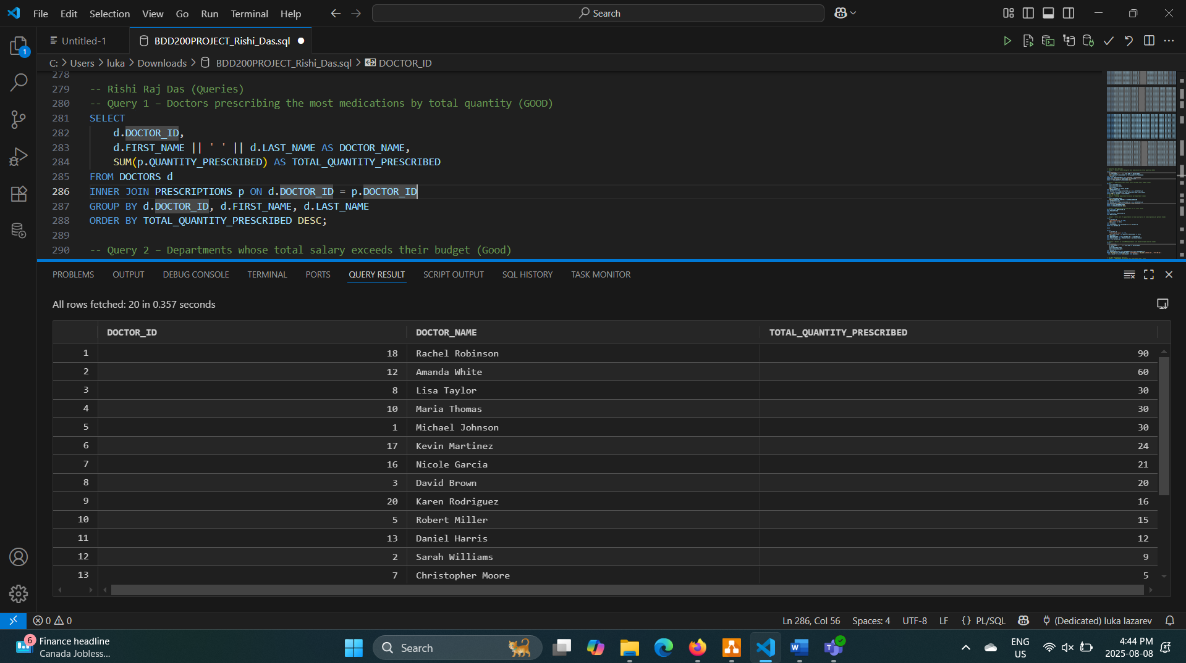

Query 2: Departments whose total salary exceeds their salary budget.
SELECT
dept.DEPARTMENT_ID,
dept.DEPARTMENT_NAME,
dept.BUDGET,
SUM(doc.SALARY) AS TOTAL_SALARY
FROM DEPARTMENTS dept
JOIN DOCTORS doc ON dept.DEPARTMENT_ID = doc.DEPARTMENT_ID
GROUP BY dept.DEPARTMENT_ID, dept.DEPARTMENT_NAME, dept.BUDGET
HAVING SUM(doc.SALARY) > dept.BUDGET;
-- meant to be blanck, no department exceeds budget.
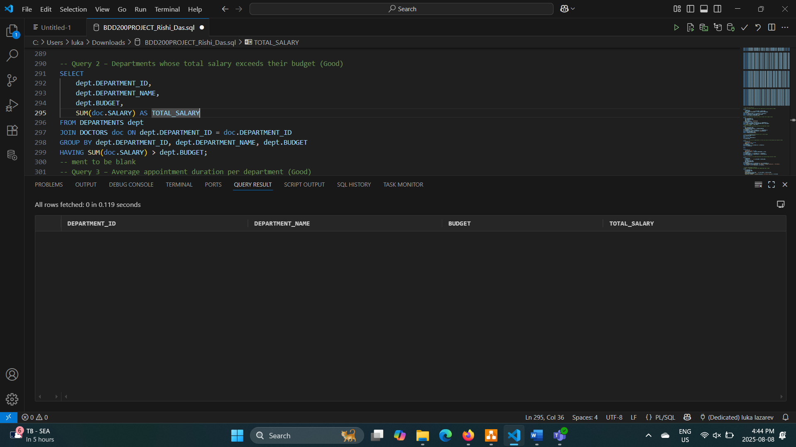
Query 3: Average appointment duration per department.
SELECT
dept.DEPARTMENT_NAME,
AVG(app.DURATION_MINUTES) AS AVERAGE_DURATION
FROM DEPARTMENTS dept
JOIN DOCTORS doc ON dept.DEPARTMENT_ID = doc.DEPARTMENT_ID
JOIN APPOINTMENTS app ON doc.DOCTOR_ID = app.DOCTOR_ID
GROUP BY dept.DEPARTMENT_NAME
ORDER BY AVERAGE_DURATION DESC;
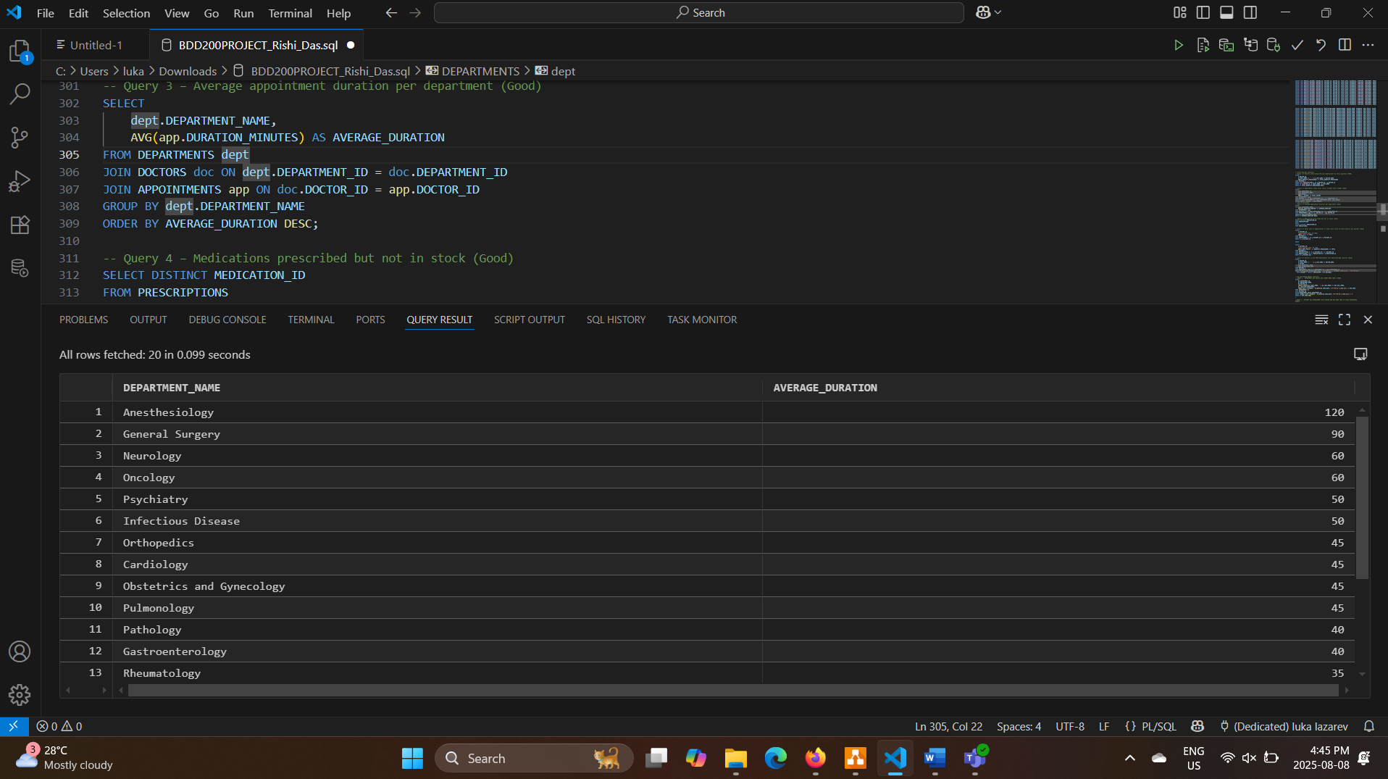
Query 4: Medications prescribed but not in stock.
SELECT DISTINCT MEDICATION_ID
FROM PRESCRIPTIONS
MINUS
SELECT DISTINCT MEDICATION_ID
FROM MEDICATIONS;
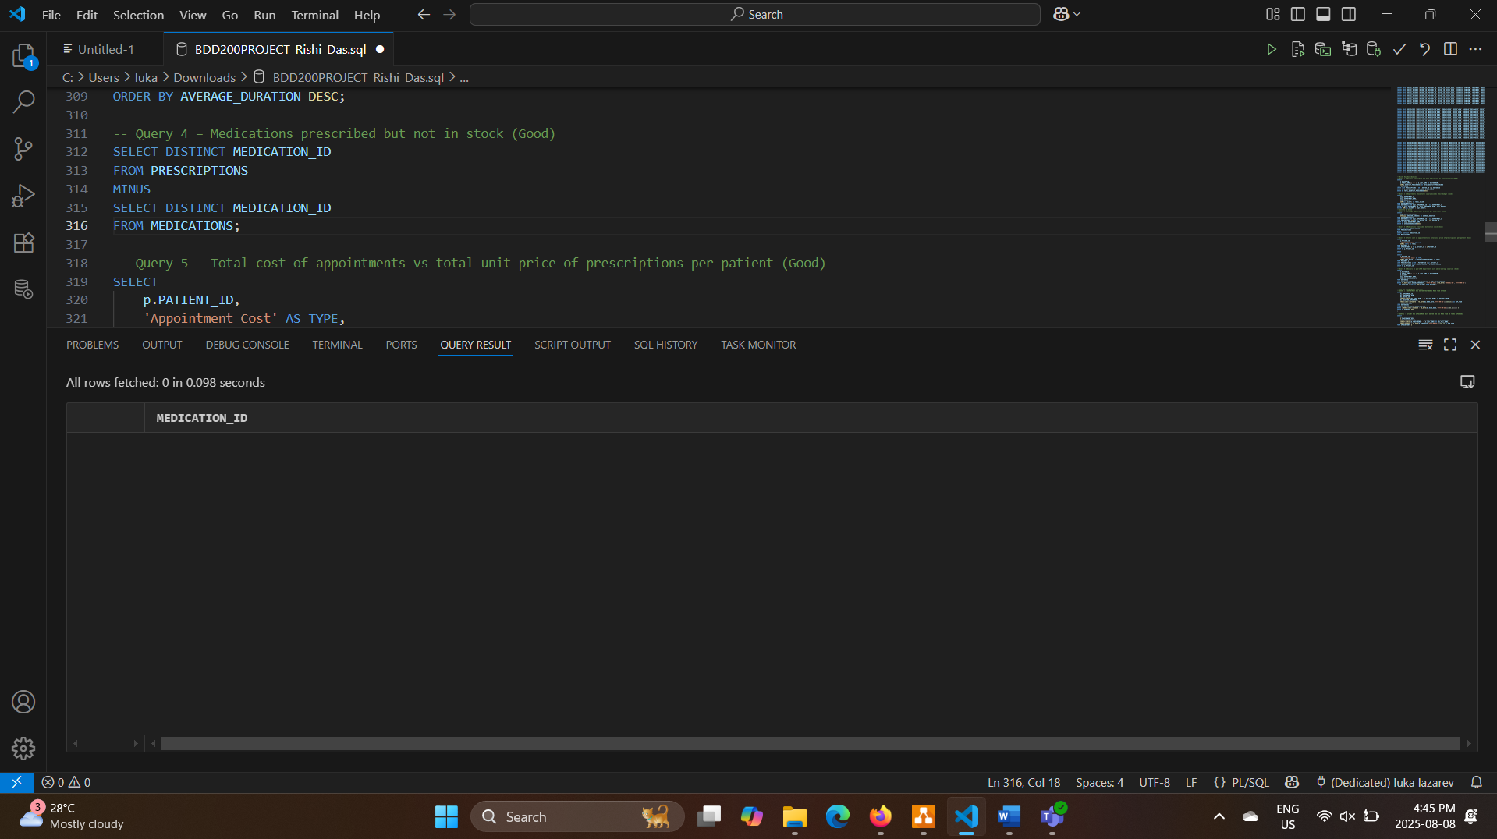
Query 5: Total cost of appointments vs total unit price of prescriptions per patient.
SELECT
p.PATIENT_ID,
'Appointment Cost' AS TYPE,
SUM(a.COST) AS TOTAL
FROM PATIENTS p
JOIN APPOINTMENTS a ON p.PATIENT_ID = a.PATIENT_ID
GROUP BY p.PATIENT_ID

UNION

SELECT
p.PATIENT_ID,
'Prescription Cost' AS TYPE,
SUM(m.UNIT_PRICE * pr.QUANTITY_PRESCRIBED) AS TOTAL
FROM PATIENTS p
JOIN PRESCRIPTIONS pr ON p.PATIENT_ID = pr.PATIENT_ID
JOIN MEDICATIONS m ON pr.MEDICATION_ID = m.MEDICATION_ID
GROUP BY p.PATIENT_ID;
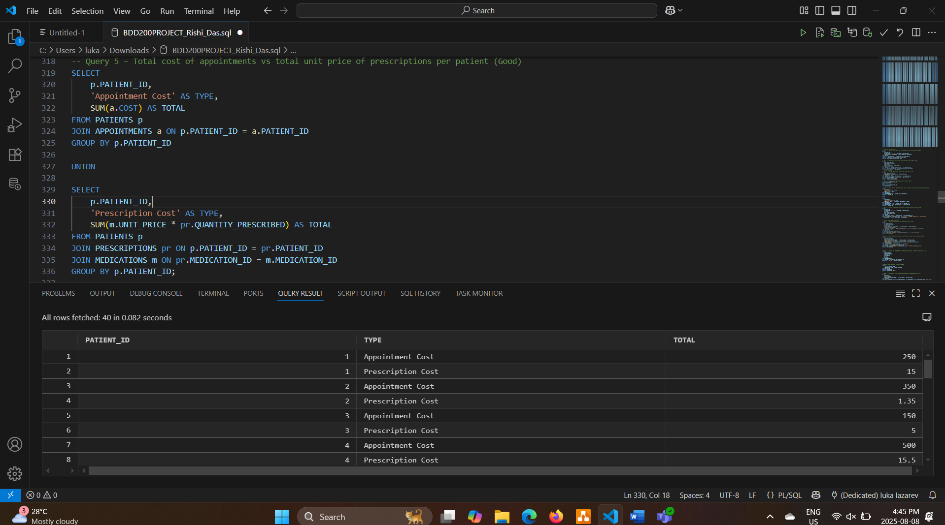

Query 6: Doctors in pre-1990 departments with above-average salaries.
SELECT
d.DOCTOR_ID,
d.FIRST_NAME || ' ' || d.LAST_NAME AS DOCTOR_NAME,
d.SALARY,
dept.DEPARTMENT_NAME,
dept.ESTABLISHED_DATE
FROM DOCTORS d
JOIN DEPARTMENTS dept ON d.DEPARTMENT_ID = dept.DEPARTMENT_ID
WHERE TO_DATE(dept.ESTABLISHED_DATE, 'YYYY-MM-DD') < TO_DATE('1990-01-01', 'YYYY-MM-DD')
AND d.SALARY > (SELECT AVG(SALARY) FROM DOCTORS);
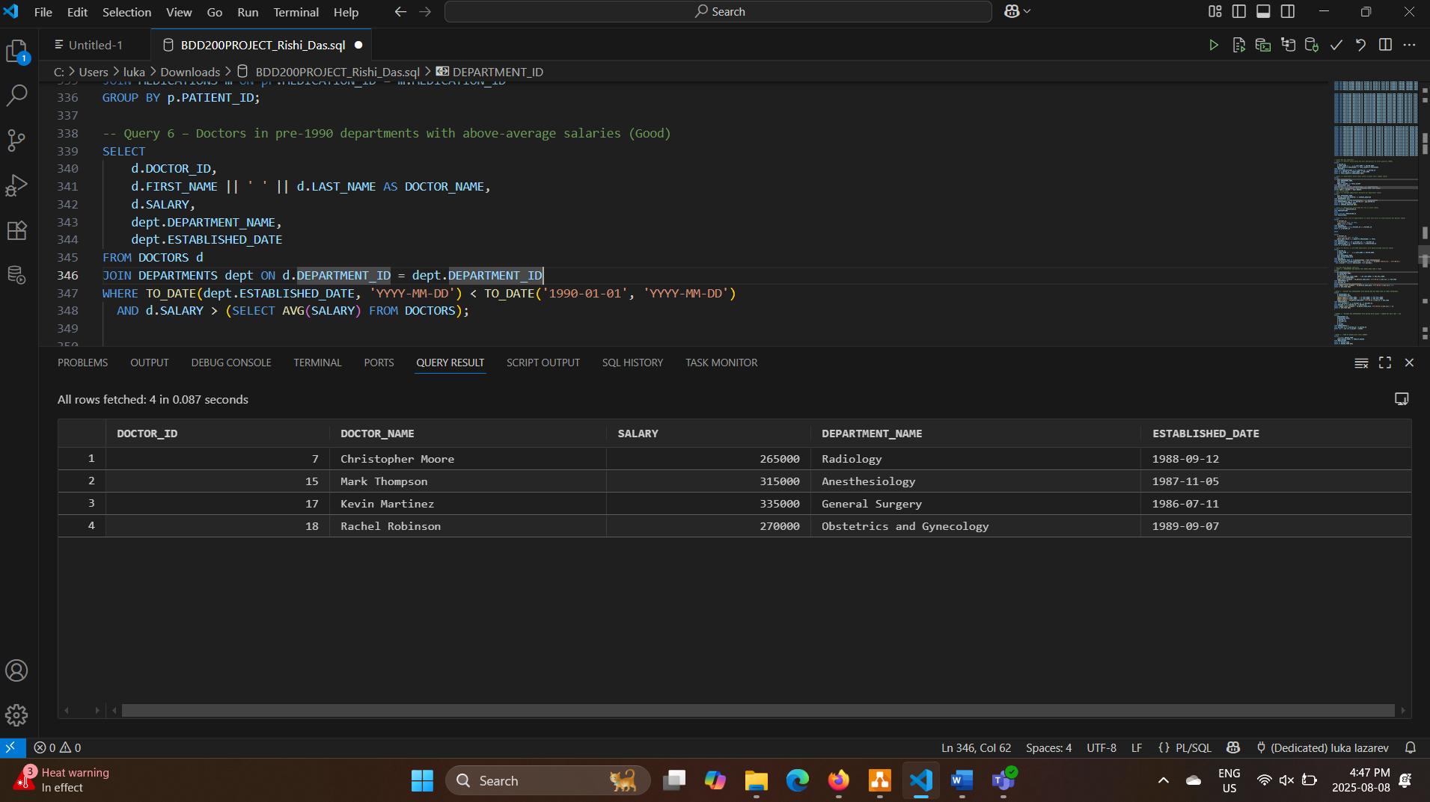

2) Luka Lazarev
Query 1: How much money does each department make?
SELECT
d.DEPARTMENT_NAME,
SUM(a.COST) as TOTAL_REVENUE
FROM DEPARTMENTS d
INNER JOIN DOCTORS doc ON d.DEPARTMENT_ID = doc.DEPARTMENT_ID
INNER JOIN APPOINTMENTS a ON doc.DOCTOR_ID = a.DOCTOR_ID
GROUP BY d.DEPARTMENT_NAME
ORDER BY TOTAL_REVENUE DESC;
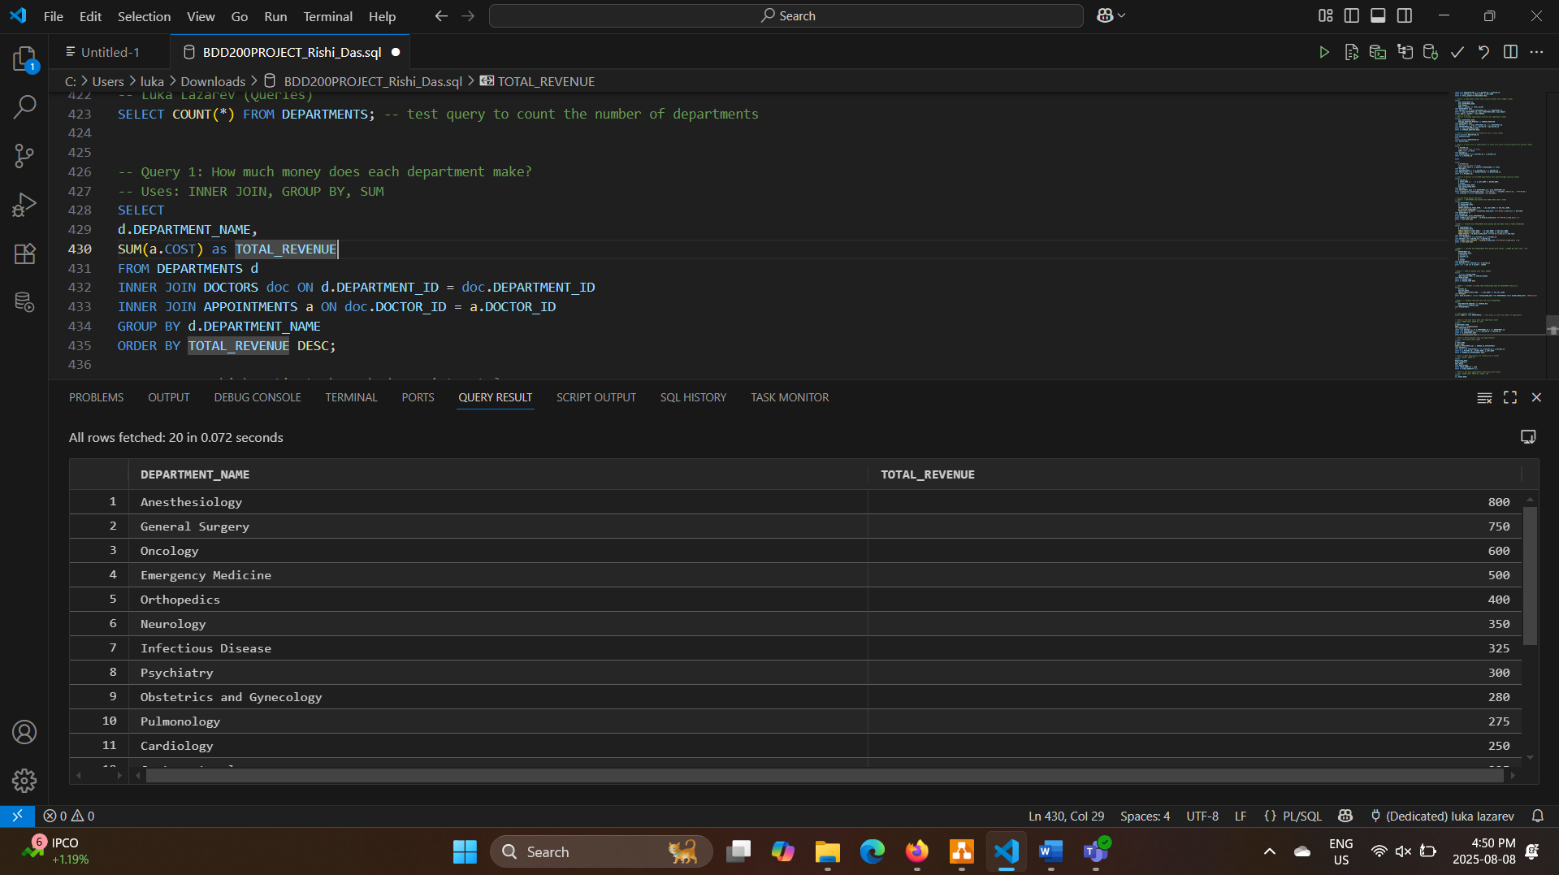
Query 2: Which patients have had appointments?
SELECT
p.FIRST_NAME,
p.LAST_NAME,
COUNT(a.APPOINTMENT_ID) as NUMBER_OF_APPOINTMENTS
FROM PATIENTS p
LEFT OUTER JOIN APPOINTMENTS a ON p.PATIENT_ID = a.PATIENT_ID
GROUP BY p.PATIENT_ID, p.FIRST_NAME, p.LAST_NAME
ORDER BY NUMBER_OF_APPOINTMENTS DESC;
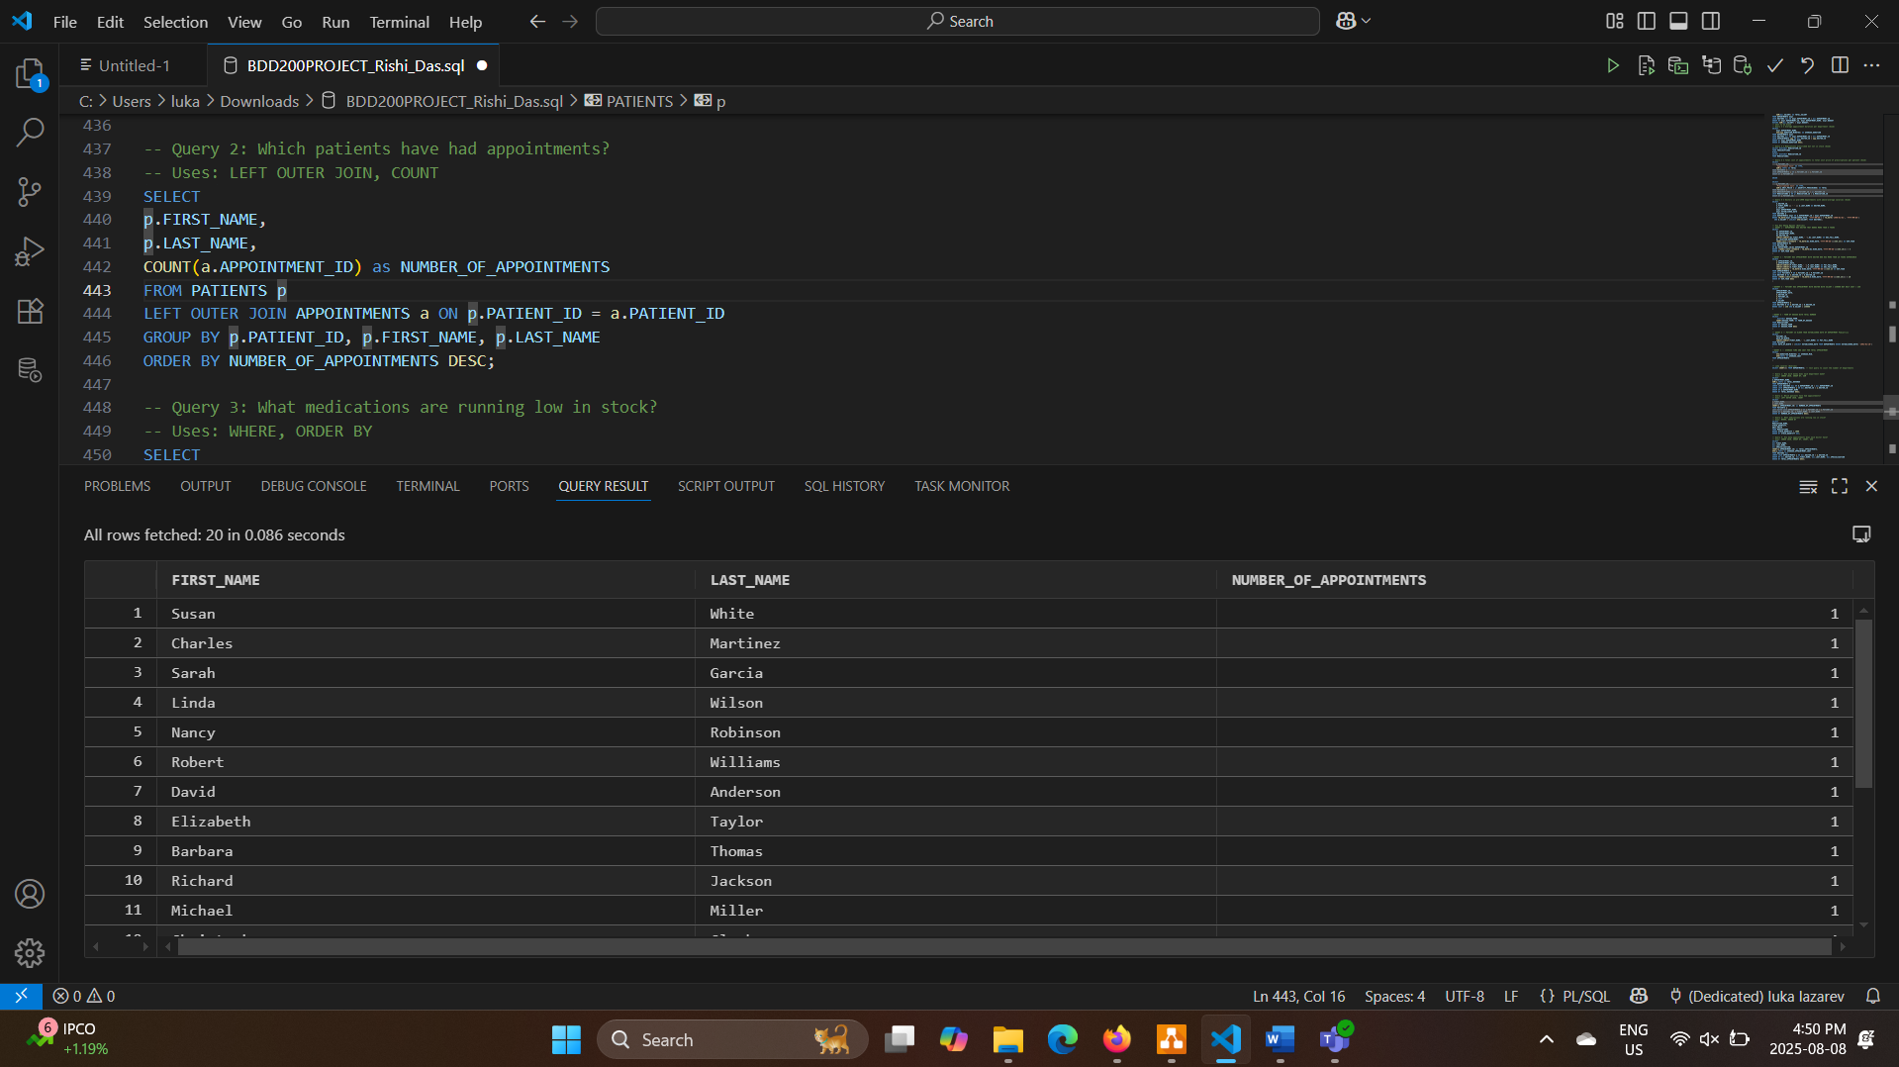
Query 3: What medications are running low in stock?
SELECT
MEDICATION_NAME,
STOCK_QUANTITY,
UNIT_PRICE
FROM MEDICATIONS
WHERE STOCK_QUANTITY < 1000
ORDER BY STOCK_QUANTITY ASC;
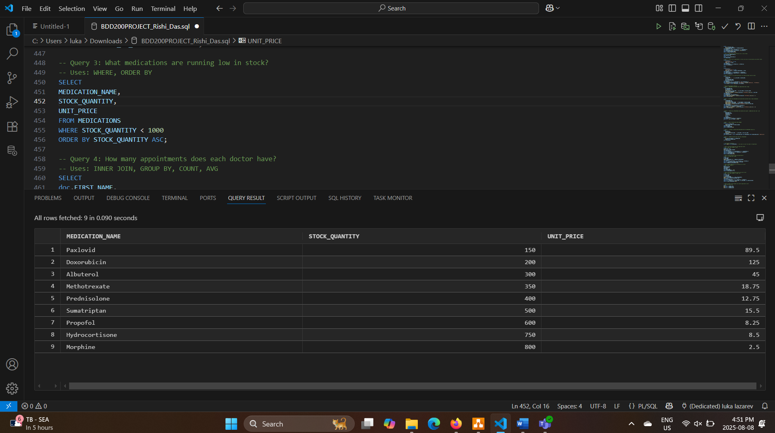
Query 4: How many appointments does each doctor have?
SELECT
doc.FIRST_NAME,
doc.LAST_NAME,
doc.SPECIALIZATION,
COUNT(a.APPOINTMENT_ID) as TOTAL_APPOINTMENTS,
AVG(a.COST) as AVERAGE_APPOINTMENT_COST
FROM DOCTORS doc
INNER JOIN APPOINTMENTS a ON doc.DOCTOR_ID = a.DOCTOR_ID
GROUP BY doc.DOCTOR_ID, doc.FIRST_NAME, doc.LAST_NAME, doc.SPECIALIZATION
ORDER BY TOTAL_APPOINTMENTS DESC;
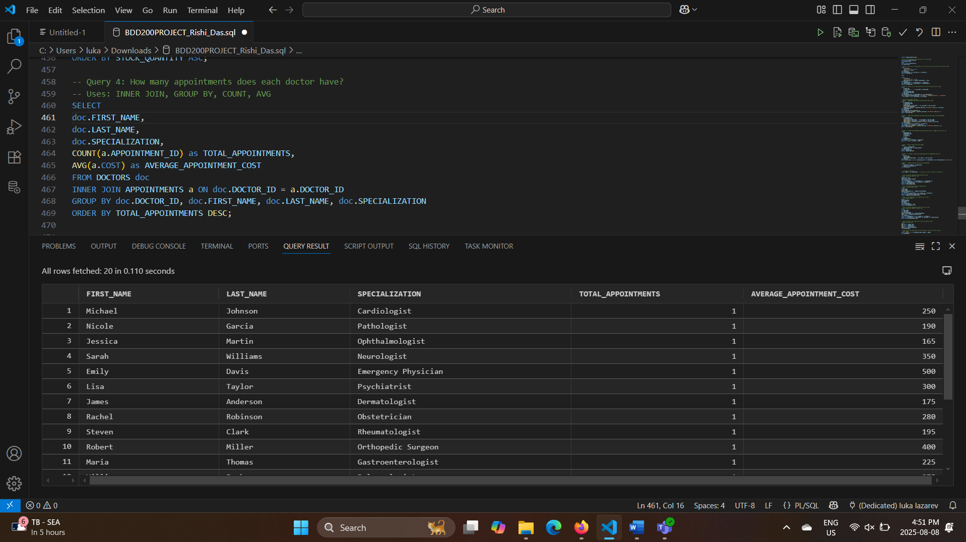
Query 5: What are the highest and lowest appointment costs?
SELECT
MIN(COST) as LOWEST_COST,
MAX(COST) as HIGHEST_COST,
AVG(COST) as AVERAGE_COST,
COUNT(*) as TOTAL_APPOINTMENTS
FROM APPOINTMENTS;
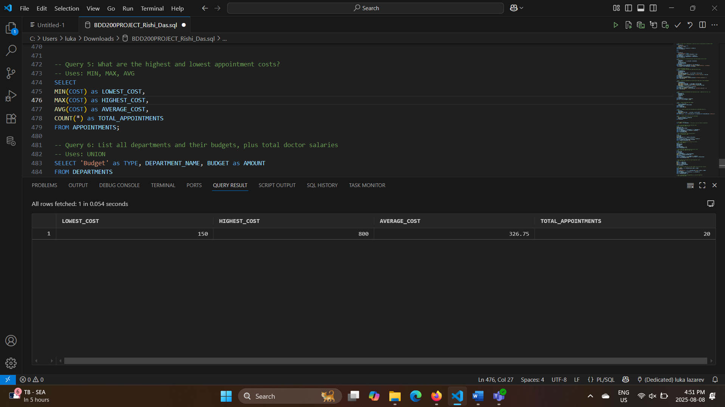
Query 6: List all departments and their budgets, plus total doctor salaries
SELECT 'Budget' as TYPE, DEPARTMENT_NAME, BUDGET as AMOUNT
FROM DEPARTMENTS
UNION
SELECT 'Total Salaries' as TYPE, d.DEPARTMENT_NAME, SUM(doc.SALARY) as AMOUNT
FROM DEPARTMENTS d
INNER JOIN DOCTORS doc ON d.DEPARTMENT_ID = doc.DEPARTMENT_ID
GROUP BY d.DEPARTMENT_NAME
ORDER BY DEPARTMENT_NAME, TYPE;
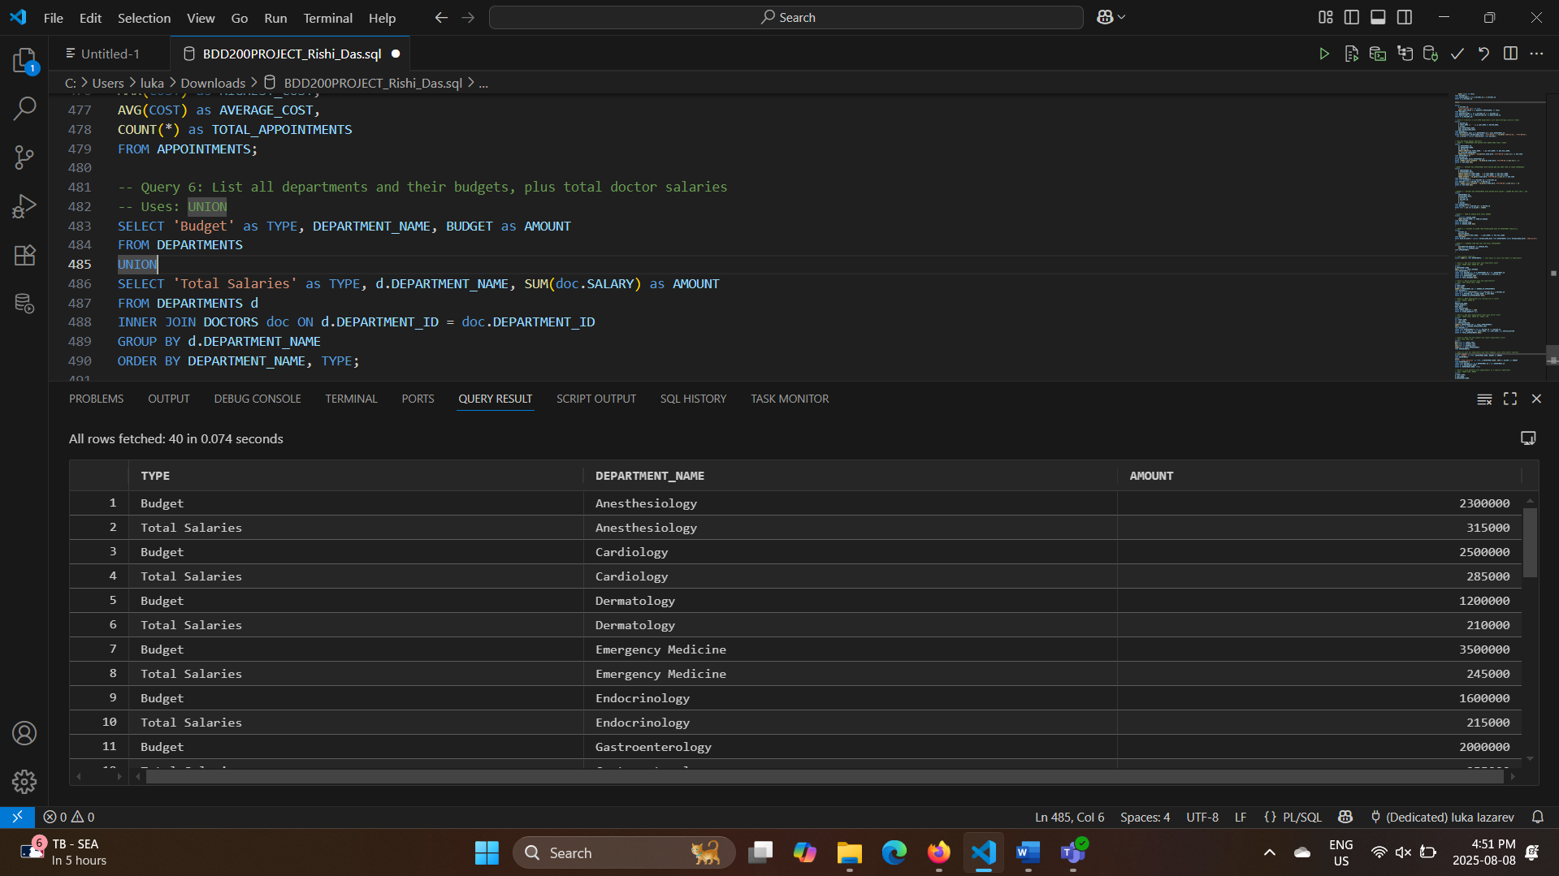

3) Duy Bao Khang Nguyen
Query 1: Departments which have doctors with more than 5 years of experience.
SELECT
D1.DEPARTMENT_ID,
D1.DEPARTMENT_NAME,
D2.DOCTOR_ID,
CONCAT(CONCAT(D2.FIRST_NAME,' '),D2.LAST_NAME) AS DOC_FULL_NAME,
D1.LOCATION_DEPARTMENT,
TRUNC((SYSDATE - TO_DATE(D2.HIRE_DATE, 'YYYY-MM-DD'))/ 365.25) AS EXP_YEAR
FROM DEPARTMENTS D1
JOIN DOCTORS D2
ON D1.DEPARTMENT_ID=D2.DEPARTMENT_ID
WHERE (TRUNC((SYSDATE - TO_DATE(D2.HIRE_DATE, 'YYYY-MM-DD'))/ 365.25)) > 5
ORDER BY EXP_YEAR DESC
;
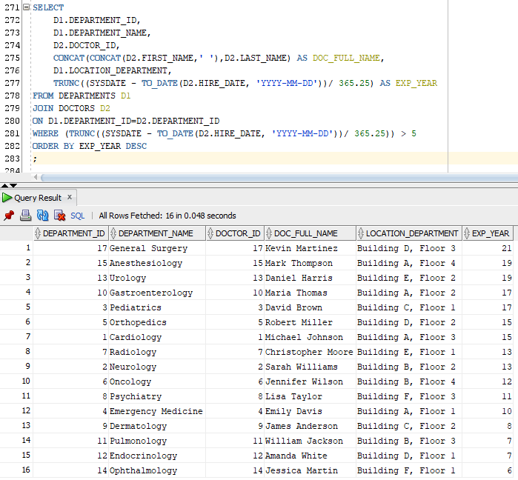

Query 2: Patients who have appointments with doctors with more than 10 years experience.
SELECT
A.APPOINTMENT_ID,
A.APPOINTMENT_DATE,
CONCAT(CONCAT(P.FIRST_NAME,' '),P.LAST_NAME) AS PAT_FULL_NAME,
CONCAT(CONCAT(D.FIRST_NAME,' '),D.LAST_NAME) AS DOC_FULL_NAME,
TRUNC((SYSDATE - TO_DATE(D.HIRE_DATE, 'YYYY-MM-DD' ))/365.25) AS EXP_YEAR
FROM APPOINTMENTS A
LEFT JOIN PATIENTS P ON A.PATIENT_ID = P.PATIENT_ID
JOIN DOCTORS D ON A.DOCTOR_ID = D.DOCTOR_ID
WHERE (TRUNC((SYSDATE - TO_DATE(D.HIRE_DATE, 'YYYY-MM-DD' ))/365.25)) > 10
ORDER BY EXP_YEAR DESC
;

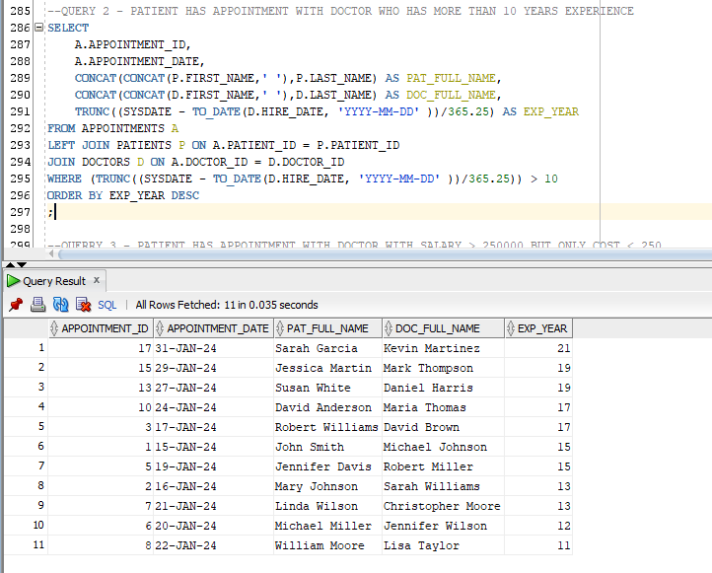

Query 3: Patient has appointment with doctor with salary > 250000 but only cost <250.
SELECT
APPOINTMENT_ID,
APPOINTMENT_DATE,
A.DOCTOR_ID,
A.PATIENT_ID,
A.COST,
D.SALARY
FROM APPOINTMENTS A
JOIN DOCTORS D ON A.DOCTOR_ID = D.DOCTOR_ID
WHERE COST < 250 AND D.SALARY > 250000
;

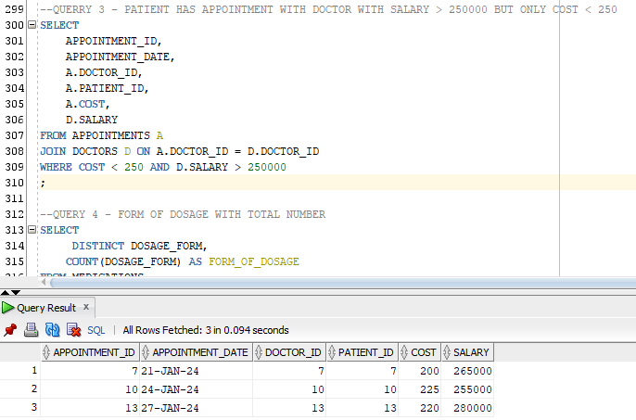
Query 4: Form of dosage with total number of dosages.
SELECT
DISTINCT DOSAGE_FORM,
COUNT(DOSAGE_FORM) AS FORM_OF_DOSAGE
FROM MEDICATIONS
GROUP BY DOSAGE_FORM
ORDER BY DOSAGE_FORM DESC
;

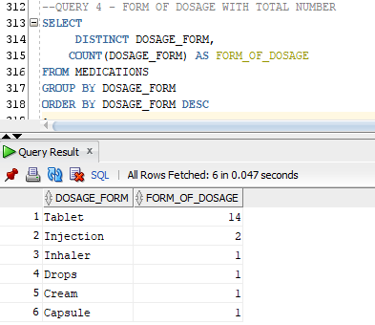

Query 5: Patient is older than established date of department Pediatrics.
SELECT
PATIENT_ID,
DATE_OF_BIRTH,
CONCAT(CONCAT(FIRST_NAME,' '),LAST_NAME) AS PAT_FULL_NAME
FROM PATIENTS
WHERE DATE_OF_BIRTH < (SELECT ESTABLISHED_DATE FROM DEPARTMENTS WHERE ESTABLISHED_DATE= '1992-01-10')
;

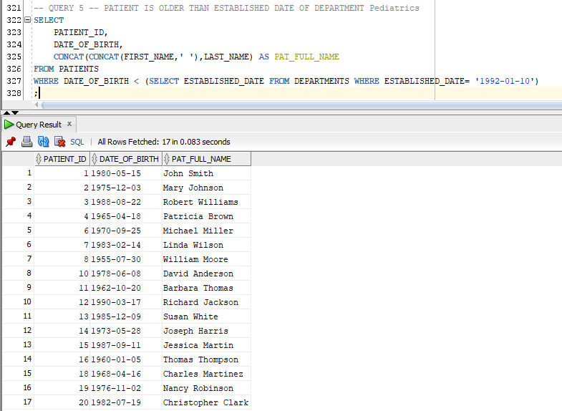

Query 6: Average time and cost for appointments.
SELECT
AVG(DURATION_MINUTES) AS AVERAGE_MIN,
AVG(COST) AS AVERAGE_COST
FROM APPOINTMENTS
;

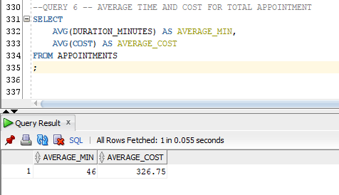

Video Link: https://www.youtube.com/watch?v=qjLX3M9MdxA

